Onondaga County Department of
Water Environment Protection
Standard for Design and Construction of Wastewater
Pumping Stations

Onondaga County Department of Water Environment Protection
Standard for Design and Construction of
Wastewater Pumping Stations

Table of Contents

- Purpose
II. Applicability
III. System Evaluation
A. Water Hammer
B. Surge Pressure
C. Hydrogen Sulfide
D. Flow Assessment
IV. Design Overview
A. Station Design
V. Site Overview
A. Site Development
1. Pavement
2. Access Roads, Driveways
B. Safety
C. Communication
D. Security
1. Fencing
2. Emergency Telephone/Camera
VI. Building Requirements
A. Building Placement
1. Soils
2. Elevation
B. Building Components
1. Roof Type
a. Flat Roof
b. Pitched Roof
2. Walls
a. Exterior Walls
i. Materials
ii. Finishes
b. Interior Walls
i. Materials
ii. Finishes
3. Floors
a. Construction
b. Drains
4. Bathrooms
5. Doors
a. Materials
b. Hinges
c. Locks
6. Stairways and Ladders
7. Loading Docks
a. Overview
i. Overhead Door
8. Lighting
a. Exterior
b. Interior
c. Emergency
9. Windows
a. Construction
b. Standards
10. Building Mechanicals
a. Heating
b. Cooling
c. Ventilation
d. Dehumidification
e. Water System
11. Miscellaneous Building
a. Work Station
b. House Pads
c. Dampers
12. Pump Wash-Down Facility
13. Communication
14. Hatch Doors
a. Overview
b. Installation
15. Fire Protection
VII. Electrical
A. Codes
B. Electric Load Estimate Sheet
C. Design Plans/Diagram
D. Testing
1. Supply Ground
2. Ground Fault
E. Pump Station Control Circuits
F. Fail Safe Design Alarm Relays
G. Branch Circuits
1. Branch Load
2. Receptacles
H. Service Panel
I. Control Panel
1. Dead Front Panel
2. Level Controls
3. PLC
4. Wet Well Control/Logic
5. Pump Operation
6. Uninterrupted Power Supply (UPS)
7. Transient Voltage Surge Suppressor (TVSS)
J. Service
K. Backup Power
L. Portable Generator Connection
M. Lightning Protection
VIII. Communication
A. Equipment (Cell Modem)
B. Station Data Relay
IX. Domestic Plumbing
A. Inspection/Permit
B. Water Service
C. Cross Connection/Backflow Prevention/RPZ
D. Miscellaneous
X. Traveling Rake Screen
XI. Interceptor
A. Location/Construction
B. Liners
C. Size/Piping
D. Hatches
XII. Grit Chamber
XIII. Valve Chamber/Meter Pit
A. Location/Construction
B. Drainage
C. Penetrations
D. Vents
XIV. On-site Fuel Storage
A. Fuel Containment Structure
B. Secondary Containment
C. Concrete Design
D. Spill Containment
E. Underwriters Guidelines
F. High Explosive Blast Resistance

XV. Pumps
A. Types
1. Submersible
2. Dry Pit Submersible
3. Suction Lift
4. Centrifugal Dry Pit
B. Standards
1. General
2. Pump Requirements
C. Construction
1. Dry Pit Submersible Pumps
2. Suction Lift Pumps
D. Priming
1. Self-Priming Pumps
2. Vacuum Priming Pumps
E. Lubrication
1. Water Pre-Lubrication
2. Oil or Grease Lubrication
F. Status
G. Seals
1. Water Seals
H. Intakes
I. Installation/Removal
J. Service
K. Pump Motors
1. Motor Wiring
L. Controls and Pump Operation
M. Variable Frequency Drives (VFD)
N. Pump/Motor Warranty
O. Pump Identification
XVI. Pump Appurtenances
A. Fittings
B. Valves
1. Gate Valves
2. Check Valves
3. Ball Valves
4. Plug Valves
5. Butterfly Valves
C. Guide Rails
XVII. Station Piping
A. Suction Lift Station Piping
B. Polyvinyl Chloride Piping
C. High Density Polyethylene (HDPE)
D. Finishes
E. Pig Launch

XVIII. Wet Well
A. Design
1. Buoyancy Analysis
B. Coatings
1. White or Light Color Wet Well Coating
C. Floor
D. Liners
1. HDPE Liners
2. Fiberglass Reinforced Plastic (FRP) Liner
E. Precast Polymer Concrete Structures
F. Wet Well Mixing/Aeration
G. Wet Well Isolation
H. Suction Well
XIX. Odor Control
A. Overview
B. Design Options
C. Decision Tree
XX. Noise Control
XXI. Station Bypass
A. Mechanics
B. Design
XXII. Flow Metering
XXIII. Pressure Gauge
XXIV. Warranty

Appendix A. Design Criteria Checklist
Appendix B. Design Component and Station Class
Appendix C. Station Photos
Appendix D. Reference Standards

Onondaga County Department of Water Environment Protection
Standard for Design and Construction of
Wastewater Pumping Stations

I. Purpose
For the purpose of these standards, the Owner shall be the governing municipality for which the pump station is built. The goal of these standards is to provide for the safe, efficient, dependable sewage pumping facilities that protect the environment. The standards establish design and technical criteria for pump stations that can be reliably operated and economically maintained by the Owner’s personnel. These requirements are provided to ensure consistency in the design approach used by the various engineers and are intended for use on all applicable projects. Technology is dynamic and so the Owner encourages open discussion in the design phase if appropriate design alternatives are developed and surpass current standards as written herein. Engineers are ultimately responsible for facility design, and this responsibility is in no way relinquished by the standards presented below.

II. Applicability
In general, the criteria apply to all public and private facilities from which mechanically conveyed sewage flows cannot readily be halted in cases of equipment breakdown or overload--potentially causing an uncontrollable raw sewage overflow. Examples of non-municipal facilities--which are extremely impractical to close and for that reason should observe these guidelines--include, but are not limited to, schools; apartment complexes; hospitals; mobile home parks; private housing; marinas; airports; prisons; large parks; resorts; and highway rest areas. These criteria apply to both package-type and site-built stations. These criteria do not apply to onsite sewage disposal systems. Also, they are not applicable to pump stations located within individual homes, factories, or manufacturing plants where, in case of failure, sewage can readily be halted and the entire station can be removed from service without risk of a sewage overflow. Most importantly, sewage pump stations shall be used only when the movement of waste cannot be accomplished by gravity.

Station Classification
Station classification shall be based on the amount of flow passing through a given facility. For the purpose of these standards and designs submitted, the following outlines classification based on flow values of:

- Class A- (small station) passing less than 500,000 gallons/24 hours
- Class B - (medium station) passing between 500,000 gallons to 7.5 million gallons/24 hours
- Class C - (large station) passing 7.5 million gallons and greater /24 hours
Station classification shall be used for expression of quantity of flow as well as a guideline for station type and equipment required.

III. System Evaluation
A. Water Hammer Evaluation
The potential impact of water hammer shall be evaluated by the Design Engineer. If the combined effects of static head and water hammer do not exceed the weakest piping system component working pressure, no special provisions need to be included to control water hammer. Where the maximum water hammer pressure exceeds the weakest piping system component working pressure, the Owner shall be notified to strengthen those elements affected, and then the pipe—including pipe size and velocities—shall be reevaluated. Selection of an appropriate device to control water hammer as prescribed by the Allievi method may be implemented. Wherever possible, spring type, oil cushioned elbow hydraulic surge relief valves are the preferred choice by the Owner. The decision to strengthen piping system components instead of utilizing a water hammer control device or different pipe size shall be based upon life cycle cost, economic comparison, and Owner preference.

B. Surge Pressure
All pump station designs shall include a surge evaluation. Surge pressure in a force main is created by any change from a steady-state flow condition; the change may range from only slight pressure or velocity changes to sufficiently high vacuum pressure or high pressure wave conditions. Events that introduce serious risk from surge are uncontrolled power failures resulting in a pump trip; rapid opening, closing, or regulating of valves; and starting or stopping of pumps. Surge control is more critical for pumping station power failure conditions and for high, specific-speed pumps that cannot be operated against closed valves.

Considerations for various equipment and means that may prevent damaging surges include:
- Automatically operated valves at the pump discharge
- Surge relief valves
- Surge tanks
- Air-oil cylinder cushioned pump check valves

The options listed above must be reviewed and presented to the Owner as applicable.

C. Hydrogen Sulfide Evaluation
A comprehensive H₂S evaluation shall be completed prior to station design. The H₂S evaluation shall provide, in ppm H₂S, the estimated levels that would be expected at the station. Because exact values are difficult to calculate, a range of values will be acceptable. Station design, wet well type and size, material type, chemical induction, and odor control are factors that will be impacted by H₂S values; therefore, it is imperative to calculate values early in the design phase. Along with the calculated H₂S range of anticipated values, it is the responsibility of the Design Engineer to provide solutions through design to abate the results of excessive values.

D. Flow Assessment
Flow estimates for station design shall be calculated based on full or projected ultimate development and sewage composition of the service area and includes the full development flow from all contributing areas at peak flow. These values must be presented to the Owner before design commencement. In developed areas, population shall be determined by house count and non-domestic user inventory with allowances made for remaining undeveloped tributary areas. Institutional, commercial, and industrial flows shall be determined by a study of the type of establishment.

The Engineer must consider that sewage composition can vary widely depending upon the proportion of design flow generated by non-domestic users. Non-domestic user sewage composition shall be investigated. Adequate consideration and necessary provisions shall be taken to ensure that sewage pumping station equipment and materials are suitable for the anticipated composition of sewage. Consultation with the Owner is required in the event that the sewage composition affects standard material and equipment requirements. The Design Engineer must also consider and accommodate for infiltration/inflow and stormwater flow in combined systems.

Flow metering during wet weather events for a period of time prior to initiation of station design may be required based on the quantity of non-sanitary flow to be pumped. Metering of sewers shall be the responsibility of the Engineer with all raw data submitted to the Owner for review prior to initial stages of design. The Engineer shall present to the Owner graphical and tabular data indicating ambient vs. wet weather flows. Discussions between the Engineer and Owner will then ensue to develop peak flow values which the station will be designed around.

IV. Design Overview
All New York State Department of Environmental Conservation requirements as well as those listed in the Ten States Standards for Pump Station Design and Function shall be followed. In addition, all standards listed below are to be followed unless otherwise indicated by the Owner.

Pump stations shall be designed as one of the following types:
- Custom built in-place wet well/dry well
- Custom built submersible
- Engineered packaged wet well/dry well
- Engineered packaged submersible

Engineered packaged sewage pumping stations must meet the requirements of these guidelines.

Submersible sewage pumps with guide rail and pump discharge elbow assemblies installed in the wet well shall be used for small sewage pumping stations. If either motor horsepower or design flow limitations for submersible type sewage pumping stations are exceeded, a dry well/wet well configuration shall be used.

Net positive suction head (NPSH) calculations shall be provided by the Engineer, at design and boundary conditions. The NPSH available, as calculated by the Engineer, shall be compared to the NPSH required by the pump manufacturer. The calculated NPSH available shall be a minimum of five feet greater than the NPSH required at design and boundary conditions.

Typically, the force main/pump system will be sized to limit the total dynamic head (TDH) to 150 to 200 feet.

A. Station Design
The design of the pump station shall include:
- A station with firm capacity to pump the peak hourly and peak instantaneous flows without overflows from the station or its collection system

- Site development including an access road and parking, security, lighting, drainage, signs, and landscaping

- Inlet, station, and force main piping with all necessary pressure control and measurement features; surge protection systems; air-vacuum/release valves; isolation valves; couplings; odor control systems; and other appurtenances required for a complete and operable pumping system

- Structures of adequate size with interior and exterior clearances to facilitate access for ease of operation and maintenance of all systems

- Plumbing systems for potable water, wash-down, and drainage

- A design consistent with EPA Class I reliability standards for mechanical and electrical components and alarms

- Mechanical systems for heating and ventilating as required by the selected station equipment, local climatic conditions, and applicable codes

- Electrical systems for lighting, power, communications, security, control, and instrumentation

- A motor control center for motor starters, accessories, and devices

- Appropriate sound attenuation for noise created by pumping, mechanical, or electrical systems

- A secondary source of electrical power

- A complete system of alarms and alarm telemetry to monitor operation and maintenance of the station at all hours

- Remote monitoring of the station through a connection with a Supervisory Control and Data Acquisition (SCADA) system

- Aspects to make the architecture of the pump station blend with the local surroundings

- All safety equipment to protect personnel

- Waterproofed underground structures

- A design that assures fire and weather resistant, durable construction

- Provisions for a suitable outlet for drainage within the building without allowing discharge across the floor including pumping glands, vacuum air relief valves, etc.

- All operation and maintenance manuals (O&M)

- All O&M records completed by the contractor and delivered to the Owner prior to the Owner’s acceptance of the facility

V. Site Overview
The site of the pump station shall:
- Provide safe access for maintenance personnel

- Allow access to the facility including construction access and be accessible during all weather or flood conditions

- Allow the conveyance of wastewater while providing sanitary protection of the surrounding environment

- Adhere to the collection system hydraulic capacity requirements

- Be situated in proximity to existing or future gravity trunk, force main, or receiving sewers

- Disallow disruption to the hydraulics of the conveyance system upstream and downstream of the station

- Consider future growth and development of communities and conveyance infrastructure

- Be sited on a piece of property where full legal proof of ownership can be obtained prior to construction

- Be selected to occupy vacant land. In new and existing subdivisions the sewage pumping station site shall occupy an area at least equivalent in size to the minimum allowable lot size.

- Conform to land use regulations such as building restriction lines and setbacks in relation to neighboring properties

- Satisfy zoning requirements and ability to obtain permits

- Be at the proper elevation and fulfill drainage requirements; i.e., above the 100-year floodplain

- Possess appropriate topography including sufficient setback to allow for fill, cut, and transition to existing contour elevations at the property lines

- Fulfill geotechnical considerations including liquefaction and landslide potential

- Consider environmental restrictions; i.e., wetlands, sensitive habitat, greenway, etc.

- Consider visual impact to the public

- Avoid difficult acquisitions when possible

- Have utilities on or near the site

- Consider sustainable operation and maintenance

A. Site Development
The following conditions must be followed regarding site design and development:

- Soil shall be graded around the station so as to lead surface drainage away from the station to an approved collection system.
- A full drainage plan of the site must be submitted to the Owner.
- Building and grounds must accommodate vehicular movement on site.
- Approach to the building, refuse containers, and fueling stations must be considered.
- Building and grounds layout must accommodate the removal of snow. This may include snow storage areas on site, multiple gate openings to push snow from paved areas, or any means to allow for snow removal without damage to the station property. To minimize grounds maintenance and such items as grass and weed cutting, the remaining non-paved areas inside the perimeter fencing shall be covered with 4 inches of crushed limestone with geotextile fabric or as dictated by the Owner.

1. Pavement
As a general rule, the following shall be used as a standard for parking lot construction. Deviations from this plan must be approved by the Owner.

Parking area sub-grade soils shall be compacted to a uniform density of ninety-five percent (95%) of the maximum density. The density will be determined in accordance with Standard or Modified Proctor density (ASTM D698 or ASTM D1557) as appropriate to the soil type. When finished, the graded sub-grade should not deviate from the required grade and cross-section by more than ½ inch in ten feet.

Parking area surfaces shall have a minimum slope of two percent (2%) or ¼ inch per foot away from the building.

The following formula may be used for the preparation and installation of parking materials:
- 10”-16” sub-base depending on soil types (gravel-clay)
- 10” Type 1 base
- 4” Type 3 binder
- 3” top

2. Access Roads/Driveways
Access roads shall be a minimum 14-foot wide with two percent (2%) cross slope to provide surface drainage. Two foot (2’) wide shoulders on each side of the road surface shall be included with a cross slope of 6 percent (6%).

Horizontal access road geometry shall permit the longest anticipated vehicular movement such that vehicle tires will remain on the driveway at all curves.
A drainage plan for the parking area shall be submitted to the Owner to assure that no collection of water occurs at any time in the parking area.

Parking lot drainage will be directed to the stormwater retention system.

B. Safety
Above-grade equipment, tanks, and piping shall be protected by permanently mounted bollards 36” in height with a minimum rating as described in ASTM M30 P1. The bollards shall be shrouded with a yellow colored reflective weather resistant plastic sleeve and placed to disallow vehicular movement as required by the site layout.

A concrete pad shall be placed around vaults/manholes which is suitable for confined space personnel-retrieval equipment. Vaults shall be designed for HS-20 vehicle loading. Site layouts must allow maintenance vehicles to access the site when the vaults are open. The surrounding concrete pad shall be sloped to conduct water away from the point of access to the vault or manhole.

The pump station buildings shall be equipped with an emergency eyewash station and an emergency spill kit, both of which will be readily accessible.

C. Communication
Communication equipment shall be provided in the pump station. This is to include hard wired telephone service with outside line, 911 link, and direct line to the Metropolitan Wastewater Treatment Plant or the Oak Orchard Treatment Plant Control Room. Devices for internet and email connection shall be provided. Communication within the facility is dependent on size, layout, and necessity for internal communication. No local horns, buzzers, or beacons shall be installed at the station to warn of equipment failure. Level/Alarm communication will be further outlined later in this document.

D. Security
1. Fencing
Security at the pump station shall include a perimeter fence. The type of fence and its style is site-dependent and at the discretion of the Owner. In the event that a fence is selected, it must be—at minimum—a continuous seven-foot high chain link fence surrounding the parking area, building, wet well, dry well, fuel storage areas, and vaults. The fence will have a minimum of one lockable opening (swing gate) suitable to accommodate the largest service vehicle plus 15 percent that would enter the station. This hinged gate must have two equal-sized sections that swing open, independently fitted with locking hardware. Roller gates that operate by an electrical/mechanical device with an automatic control (card and pressure controller) may be incorporated in the design as indicated by the Owner. Lock(s) for the gate will be provided by the Owner. The entrance gate will be located on the main drive from the street entrance. The site security fence and entrance gate shall be placed far enough from the street to allow maintenance vehicles to be off the main roadway when maintenance personnel stop to unlock the gate. All exposed fencing materials shall be black vinyl coated. In areas particularly subject to vandalism, higher fences and electronic security systems should be considered on a case-by-case basis. Where the operational activities inside the pumping station may create environmental nuisance or are visually intrusive, a solid boundary wall with suitable architectural features may be considered.

2. Emergency Telephone/Camera
An emergency hard wired telephone shall be mounted outside the building on a post or similar mounting device, not attached to the building. This phone is to be accessible by foot in all weather and wired for communication with 911 and the Metro Board in the event of an emergency. The phone shall be fitted within a weather proof case and have a light mounted on top to indicate location. The station will be supplied with—at a minimum—one (1) outdoor and one (1) indoor camera producing high definition color digital images and optional video with a 700 dpi or better rating that will be wired to the SCADA or remote system for full remote control. The outdoor camera will be oriented in such a way as to see the entrance gate. The indoor camera will be located as dictated by the Owner. Cameras and recording/logging equipment must meet current requirements of the Owner so as to be incorporated into the Owner’s department-wide system.

VI. Building Requirements
A. Building Placement
1. Soils
The pump station building shall have a foundation design based upon geotechnical evaluation of underlying bearing stratum. The design professional shall include the geotechnical report and soil boring report in the project specifications. Depth of borings shall be extended at least 20 feet below the planned foundation base; actual depth is to be determined by the Engineer and the geotechnical engineer. The seismic site-specific soil classification shall be provided by the registered professional geotechnical engineer preparing the soil investigation report in accordance with ASCE 7-05. Unless indicated by special site considerations, evaluation of soil corrosivity is not required.

2. Elevation
The pump station building shall:
- Be elevated to a minimum of three feet above the 100-year flood elevation, or protected to such elevations
- Have the location of the slab elevation (if the above-mentioned elevation minimums are satisfied) be based on adjacent lot pad elevations. In the absence of adjacent lot pads, the slab elevation shall be set based on a minimum rise of two percent from the edge of pavement or a minimum one (1) foot above the crown of road, whichever is greater.
- Have the distance from the front of the pump station to the front lot line not be less than the front setback of the nearest adjacent lot
- Be placed no closer than 100’ from the closest inhabited building

B. Building Components
1. Roof Types
Roof types will be selected based on the location, type, and size of the structure required. The following outlines required roof materials based on the desired roof type.

- Flat Roof Coverings
In addition to local building codes, flat roof coverings shall adhere to the following standards for material and installation:
- For Single-Ply Roofing Membrane refer to standard: ASTM D4637/D4637M
- For Spray polyurethane foam-based (SPF) roof system, refer to standards ASTM C1029 "Specification for Spray Applied Rigid Cellular Polyurethane Thermal Insulation"
- ASTM D6083 "Specification for Liquid Applied Acrylic Coating Used in Roofing"
- ASTM D6694 "Standard Specification for Liquid Applied Silicone Coating Used in Spray Polyurethane Foam Roofing Systems"
- ASTM D6947 "Standard Specification for Liquid Applied Moisture Cured Polyurethane Coating Used in Spray Polyurethane Foam Roofing System"
- ASTM D7425 "Standard Specification for Spray Polyurethane Foam Used for Roofing Applications"

- Pitched Roof Coverings
Pitched roof coverings shall adhere to the following standards for material and installation, in addition to local building codes:
- Pitched roof coverings shall either be metal sheeting or asphalt shingle. Asphalt shingles and metal sheeting shall have a minimum of thirty (30) year or better manufacturer’s warranty.

- Roof decking material (wood) shall be a minimum of 5 ply ½” plywood installed with binding clips (i.e., Teco brand or equivalent) spanning the adjacent plywood sheets between trusses/rafters. Asphalt shingles will be applied over #30 felt paper that is nailed to the roof deck; staples are not acceptable. Roof edges and valleys must be protected with an initial layer of ice and water barrier rated at least 30 years.

- Aluminum drip edge shall be no less than 26-gauge and colored to match roofing materials.

- Metal roofing shall be 24-gauge Teflon coated aluminum. Metal roofing shall be of the type that has the likeness in appearance to asphalt shingles. Vertical roof lines, as visible from the curb, are unacceptable. Metal roofing material shall be colored to enhance the appearance of the building; unfinished or uncolored metal roofing is unacceptable. If applicable, exterior eave overhangs shall be constructed of low maintenance materials such as metal or vinyl soffit panels.

- Building roof drains and site drains shall connect to the stormwater system.

- Roof venting is required and can either be of the gable or ridge vent type. Gable vents shall be painted aluminum.

- All roof penetrations must be flashed and sealed as to disallow water from entering the roof deck.

- All roofs must be oriented so water, snow, and ice do not discharge in an area of an overhead or entry door, hatch, mechanical, or electrical equipment.

- All roofing materials shall be installed as per manufacturer’s directions to maintain warranty on all installed products.

2. Walls
a. Exterior Walls
i. Materials
Exterior walls of the pump station shall be constructed from concrete masonry units (CMU) with brick facing. Other exterior finishes will be determined by the Owner depending on the proposed location and surroundings of the station.

Brick facing must comply with standards that meet ASTM C216-97 (or latest version), Grade SW (Severe Weathering), Type FBX, with color to be determined by the Owner. Brick size as dictated by the structural engineer.

The exterior walls shall display the name of the pump station with raised 6” stainless steel block lettering. The 911 address shall be displayed on a reflective plaque with 4” white lettering set on red background and shall be attached on the street side of the building, or as dictated otherwise.

ii. Finishes
A sacrificial, clear anti-graffiti coating shall be applied to all exterior vertical building walls as deemed necessary by the location and Owner’s preference.

b. Interior Walls
i. Materials
Where applicable, interior walls shall be constructed of steel stud/track as per Steel Stud Manufacturers Association guidelines with 5/8” Fire/Moisture resistant sheetrock that is UL Classified and UL listed for fire resistance. Sheeting must qualify as water resistant gypsum backing boards as defined in ASTM C 1396 and mold resistance as per ASTM D3273 or equivalent.

ii. Finishes
Interior wall surfaces shall be painted with a minimum of 2 coats of semi-gloss water based epoxy coating. The paint shall be of quality and type to withstand general cleaning with water and, where appropriate, pressure washing. (i.e. wash-down station, screens area).

3. Floors
a. Construction
Pump Station floors shall:
- Have an elevation at least six inches above finished grade
- Be reinforced concrete, having a design thickness to support the rating of the heaviest equipment load plus 10 percent as dictated by the structural engineer
- Have a clear seal applied following curing.

- Drains
All floors, in each room of the station, shall have a drain provided that directs discharge back to the wet well or sewer as appropriate. Piping of the drain will include a trap or other such means as to disallow odors from the wet well coming back to the station. All floors must be drained in such a manner that the quality of the potable water will not be endangered.

4. Bathrooms
Bathrooms within the pump station shall be equipped with:
- A unisex facility including white porcelain urinal/standard low flush toilette with power-assist flush, motion activated toilettes, stainless steel faucet operators, hand dryers/towel dispenser, and soap dispenser
- Standard, single stall white fiberglass shower
- 24”x24” minimum wall mounted mirror
- Stainless steel utility sink measuring no less than 24”w x 24”deep x 24”high with gooseneck touchless faucet operators
- Tiled walls extending from the floor to a minimum height of 36 inches, color/pattern as dictated by Owner
- Motion/light activated light switch with manual over-ride
- 2” stainless steel floor drain
- Stainless steel garment hooks (minimum of 4)
- Solar lighting provided through the use of a 10” minimum diameter sun tube or solar tube, where applicable
- A 24” long, 2” diameter stainless steel grab bar located next to the toilette.

5. Doors
a. Materials
Exterior and interior personnel doors and frames shall be of hot dip galvanized, insulated steel construction and painted as dictated by the Owner. Where security is a concern, stainless steel frames and doors shall be used. All active leaves of doors shall be equipped with closers. Exterior doors shall be equipped with door stops. Hold-open devices shall be provided at doors used for moving equipment. All exterior doors shall be fully weather-stripped and provided with thresholds. Interior doors, with the exception of those used for lavatory, shall have a screen reinforced observation window measuring no less than 10” x 10.” Doors must meet the standard AAMA 1303.5 for forced entry resistance.

- Hinges
Hinges shall be ball bearing, extra heavy weight, stainless steel finish, satisfying BHMA 156.1 standards. Exterior door hinges shall include a non-removable pin.

- Locks
Locks and latches shall be lever–handled mortise locks satisfying BHMA 156.13, series 1000, Grade 1 with stainless steel lock case and finish and non-ferrous or corrosion resistant working parts. Doors to the exterior of the station shall use “crash bars” on the inside of the door to activate the latch and allow exit from the building. Locks shall allow personnel to secure the door from the inside to provide security while performing maintenance operations. The contractor shall provide locks with interchangeable cylinders that can be keyed to the Owners standards. Locks shall be deadbolt type keyed to Owners standard or equal. The Owner is responsible for changing the lock core after construction is complete.

6. Stairways and Ladders
Stairways, landings, and ladders shall:
- Conform to the requirements of the International Building Code, OSHA Standard 1910.24 Fixed Industrial Stairs parts a through i, as well as applicable state and local codes
- Be provided between all floors and in pits or compartments which must be entered
- Be outfitted with current safety equipment, fall protection, railings, and signage
- Have optimum lighting that casts no shadows in walkways and provides full illumination of all stair treads, landings, and rungs
- Have a load rating that accounts for the maximum anticipated weight as determined by the Engineer plus 10 percent
- Be grounded if made of stainless steel or other conductive material

Unless otherwise indicated by the Owner, stairways, handrails, stair landings, ladders, and fasteners shall be constructed of Type 316 stainless steel. Ladders and stair landings may be constructed of fiberglass depending on the applicability and at the discretion of the Owner. Fall protection shall be provided to service ladder locations as dictated by the Owner.

7. Loading Docks
a. Overview
The delivery and removal of potentially heavy equipment in and out of the station and regular loading/removal of screenings requires a custom loading dock. A dock system shall be designed that will be safe, useful, and aesthetically pleasing.

The loading dock shall:
- Consist of an appropriately sized galvanized metal overhead manually operated door, heavy duty dock bumpers, lighting, safety signage/striping, railings, security fencing/cage, and trolley/dock crane as needed. Dock bumpers shall be installed at a working height as indicated by the Owner.
- Be constructed of reinforced concrete rated for the calculated weight of the heaviest equipment passing through the loading dock plus 10 percent. Design of the dock shall disallow roller dumpsters from being rolled over the edge of the loading dock to the surface below.
- Include prevention of surface wear caused by screenings removal and container movement shall be mitigated through appropriate concrete coatings or use of wear pads, as needed.
- Have grounded, stainless steel stairs shall be provided for access to the loading dock from grade level. Stairs shall be situated to disallow the accumulation of snow in, on, and around entry stairs.
Drainage of the dock area is to be provided to prevent any water/ice accumulation on the surface and shall discharge to the on-site collection system. The loading dock shall also be equipped with a 40” wide minimum entrance door to allow entry to the station without going through the overhead roller door.

i. Overhead Door
The overhead door shall be an insulated roller overhead door made of 20-gauge, hot dipped galvanized epoxy-primed polyester top-coated steel; the loading dock door must be securable from the inside of the building. In buildings where high H₂S values are anticipated, fiberglass roll type overhead doors will be used.

8. Lighting
Pump stations shall be adequately lighted throughout to deter vandalism and facilitate station maintenance. All electrical work shall conform to the requirements of the National Electrical Code (NEC) and to relevant state and local codes. Explosion proof fixtures, bulbs, and switches shall be used where applicable.

a. Exterior:
Exterior lighting at all entrances and loading areas to the building will be provided and activated by a motion detector. Exterior lights will activate at a minimum of 25’ upon approach. Lighting must cast to allow clear visibility of all entrances, external generator, generator fuel tanks and emergency telephone. Automated fixtures with manual override shall stay illuminated a minimum of ten minutes upon activation. Lighting fixtures must be fitted with LED bulbs or bulbs requiring equivalent power or less for operation with no decrease in illumination. Low-level exterior evening lighting compatible with the surrounding area shall be provided and mounted on a pole(s) or a minimum of 8’ above grade so that all sides of the exterior of the pump station can be seen clearly during evening hours. External lighting, in particular floodlights, shall be so located and orientated to avoid inducing glare affecting the neighborhood or nearby road users. Two levels of external lightings should be provided, i.e. general lighting for security purposes and task lighting for particular operation and maintenance activities. Timer control, remote control, photo-sensor, and bypass switches for the external lightings will be provided as appropriate.

b. Interior
It is the preference of the Owner to have, at a minimum, 25 percent of all lumens required for proper daytime visibility in the station to be provided through solar lighting. Solar lighting provided through the use of 10” minimum diameter Tubular Daylighting Device (TDD) and skylights shall be provided where applicable. Calculations for lumen requirements and proposed electric and solar output shall be provided to the Owner prior to design completion. The Owner shall dictate the final percentages of solar and electric lighting used. No sun tube or solar lighting shall be installed directly above any electronic equipment or panels. Permanent lighting in hazardous locations must meet with Owner approval.

An emergency, generator-powered lighting system shall be provided in the station. Lighted exit signs at the station access doors that are interconnected with the emergency lighting system will be provided as per national/local fire code. Emergency lighting shall also allow for illumination of the control panel, communication equipment, and essential halls/stairs as required for safe movement through the facility.

c. Emergency
As a backup in the event of a power and generator failure, battery operated lighting will be provided. This lighting will be tied to the exit signs, provide illumination to the generator area, and all walkways that allow exit from the station.

9. Windows
The use of windows is at the discretion of the Owner and station dependent. Considerations for the usefulness and installation of windows include lighting need, specific location, safety, security, and aesthetics. Windows used in the station must not be operable.

a. Construction
Windows must be silicon-glazed for greater strength and seal and frames constructed of extruded aluminum with electrostatic paint finish.

b. Standards
The following standards shall be followed for windows used in the station:
- Corrosion-resistant hardware and fasteners with stainless steel options
- Passes large and small impact tests
- Passes ASTM E547/E331 water penetration
- Passes ASTM E283 for air leakage
- Deglazing test (ASTM E987)
- Uniform Design and Structural load test (ASTM E330)
10. Building Mechanicals
All heating and cooling units must be Energy Star certified, where applicable.
a. Heating
The heating system for the pump station will be dependent on the facility size and layout. High-efficiency and standard units of the types listed below must be presented to the Owner with anticipated costs including purchase, installation, operation, and maintenance of the heater. Maintenance and operation costs provided to the Owner will include a five-year minimum projection. Heating units must be appropriately sized for minimum heating requirements. As a general rule, the amount of heat necessary for the station is that amount required to keep pipes and other water containing equipment from freezing. An indoor temperature of 54°F and an outdoor temperature of 20°F should be used for general heating design, unless otherwise required by equipment manufacturers or stipulated by the Owner. Note that the required temperature of 54°F must be maintained in the station and wet well area regardless of outdoor temperatures that are at or below 54°F. Where indicated by the Owner, a redundant heating system may be required in the event of a primary system failure. Heating units in close proximity to the wet well areas must meet the requirements of the most recent edition of NFPA 820. Heaters and thermostats must be installed away from sensitive electronic equipment.

Acceptable heater options include:
- Natural Gas Boilers
- High Efficiency Natural Gas Unit Heaters
- High Efficiency Natural Gas Forced Air Furnace
- Electric Unit Heater

In the event that a boiler is selected as the preferred heater type, equipment must meet all current ASME Boiler and Pressure Vessel Code requirements. Additionally, all zones which are fed from a boiler must be alarmed to the SCADA system for low and high temperatures in the heating system. Set points for alarm condition shall be when temperature in the system extends below 42 F and above 230˚F. System pressure shall also be alarmed with a high set point of 40psi. Water drains from boiler units must be conducted to a designated drain that is tied to the wastewater system of the facility.

Provisions shall be made for adequate heating for:
- The comfort of the operator
- The safe and efficient operation of the equipment

In pump stations not occupied by personnel, the heat required is to assure proper operation of equipment and treatment processes.

b. Cooling
The amount of cooling required shall be based on equipment, motor, and device requirements. Cooling units shall only be installed where control equipment or other devices are housed, not the entire facility. Because of the range of cooling equipment available and temperature fluctuations within a facility, it shall be the responsibility of the Engineer to calculate and present to the Owner a range of anticipated temperatures throughout the seasons of the year and equipment that may control cooling. Estimated annual operating costs of 3 different cooling units shall be presented to the Owner, whom will ultimately decide which to install.

c. Ventilation
Ventilation shall be adequate to ensure that equipment, motors, and devices, including sensitive electronic equipment, are operated in their intended design temperature range. Ventilation shall conform to relevant state and/or local codes. Adequate ventilation shall be provided for all pumping stations for operator comfort. Forced ventilation of at least six (6) changes of air per hour shall be provided for all confined rooms, compartments, pits, and other enclosures below ground floor or any area where unsafe atmosphere may develop or where excessive heat may be built up. This does not include wet wells.

Wet wells shall be provided with a separate ventilating system and control—sized to provide a minimum of 15 complete air changes per hour. Ventilation shall be accomplished by the introduction of fresh air into the wet well under positive pressure. If the fan is installed outdoors, the fan assembly and housing shall be of corrosion-resistant and weatherproof construction--stainless steel preferred. The entrance hatch to the wet well shall be provided with a limit switch to energize the fan whenever the hatch is open. The fan shall be direct drive.

Dry wells shall be provided with a separate ventilating system and shall be sized to provide 10 air changes per hour. Ventilation shall be accomplished by the introduction of fresh air into the dry well under positive pressure. Precast dry well ventilating fans shall be continuously energized whenever the access hatch is open.

Control rooms and MCC rooms, if separate, shall be ventilated under positive pressure; meaning that these areas will disallow suction of cool, moist air from areas such as the wet well which may damage sensitive electronic equipment. The design may include a vestibule area immediately adjacent to control rooms that would allow pressure balancing of the atmosphere prior to entry to these sensitive areas.

All motor operated dampers/louvers shall be of heavy-duty aluminum design and of airtight, moisture proof energy efficient construction rated for damp environments.

d. Dehumidification
Dehumidification shall be provided in areas where excess moisture could cause hazards for operator safety or damage to equipment. Areas that are regularly occupied by personnel shall have a relative humidity of 50 percent to 60 percent unless otherwise indicated by equipment manufacturers’ recommendations. Dehumidification equipment shall be high efficiency and capable of removing .035 to .05 pints of water per square foot per day minimum.

Humidity shall be constantly monitored at the station; therefore, equipment to do so shall be included by the Engineer in the design. Because of the range of equipment available and humidity fluctuations within a facility, it shall be the responsibility of the Engineer to calculate and present to the Owner a range of anticipated humidity values throughout the seasons of the year and equipment that may control it.

e. Water System
Where public water is available, a metered 1” minimum connection from the existing water system shall be made, and water for the purposes of sanitary use at the station, flushing and sewage pumping station wash-down, and pump water seal shall be provided. A larger diameter supply may be required at the station depending on the requirements of the wash down system and seal water demands. Where required by design, an alarmed “Hot Box” shall be provided to prevent freezing of water at the RPZ. If there is no existing water supply system, a well and bladder-type hydro-pneumatic tank or other such water reservoir with booster pump shall be installed at custom built-in place stations; the Owner will determine the need for and location of well and equipment on package stations.

Stations that require seal water for pump operation must be alarmed in the SCADA system for low water pressure.

11. Miscellaneous Building
a. Work Station
Unless waived by the Owner, a three-foot by four-foot bulletin board shall be provided in a well-lit area of the control room for posting operating information with an adjacent shelf to hold Operations and Maintenance manuals and other reference material. Each shall be placed in a suitable and functional location, as approved by the Owner. A permanently mounted podium or work station with a hard wired phone and duplex 120v AC outlet available for computers/additional lighting will be provided adjacent to the reference area. This area must also have wiring to allow for connection to the internet as well as the County SCADA system.

b. Housekeeping Pads
Housekeeping pads shall be provided under all floor mounted equipment.

- Dampers
All dampers and other such building penetrations shall have bird screening attached where appropriate. Assume all openings are to be covered unless otherwise indicated by the Owner.

12. Pump Wash-Down Facility
Each pump station with four or more pumps shall contain a three-sided, 6 feet tall pump wash down facility. It shall be sized to accommodate the largest pump with a minimum clearance of 3 feet around the pump. The facility shall consist of a minimum 12-inch reinforced, sealed concrete slab with epoxy coated concrete masonry unit (CMU) walls. The slab shall be sloped to the rear wall with a 6-inch valved drain which shall terminate in the pump station wet well. The wash-down area shall also be provided with a hand operated spigot to receive a standard Garden Hose Thread (GHT) 1-1/16” hose used for equipment washing.

13. Communication
Communication equipment shall be provided in the pump station. This is to include hard wired telephone service with outside line, 911 link, and direct line to the Metropolitan Wastewater Treatment Plant or Oak Orchard Treatment Plant Control Room. Devices for internet and email connection shall be provided. Communication within the facility is dependent on size, layout, and necessity for internal communication. No local horns, buzzers, or beacons shall be installed at the station to warn of equipment failure. Level/Alarm communication will be further outlined later in this document.

14. Hatch Doors
a. Overview
Hatch doors used at the pump station for vault and wet well access, where applicable, shall include the following:
- Aluminum diamond plate doors rated for direct traffic loading
- Auto-lock Type 316 stainless steel hold open arm with release handle
- Type 316 stainless steel hinges and attaching hardware with tamper proof fasteners
- Type 316 stainless steel slam lock with removable key
- Stainless steel compression spring or gas charged cylinder lift assist
- Extruded aluminum frame
- Recessed lifting handle
- Fall protection (at the direction of the Owner)
- Gutters on all frame channels
- Lifetime guarantee

b. Installation
Installation of the hatch door shall include a full bed of Class “A” concrete under the frame and support angles. Doors shall close flush with the frame. The inside of the frame shall have a door-support ledge on four (4) sides. A maximum allowable door deflection shall be ¹/₁₅₀ of the span for all loads. Doors shall open to ninety degrees (90˚) and automatically lock. Unit shall carry a lifetime guarantee against defects in material and/or workmanship.

15. Fire Protection
Pump stations which include a building shall have a New York State fire classification code of Utility and Miscellaneous Group (U). New York State code shall be followed for:
- Fire
- Building
- Fuel Gas
- Plumbing
Also, all fire codes of NYS shall be followed for fire access roads in addition to driveway requirements as outlined previously in this document. For pump stations that will store and implement the use of chemicals for odor control or other uses, refer to Chapter 27 of NYS Fire Code regarding hazardous material - 2010 version or current for all aforementioned regulations.

Pump stations shall be equipped with hard wire, fully integrated smoke and carbon monoxide detection equipment.

VII. Electrical
A. Codes
Pump station electrical systems shall be designed to meet Class 1 Group D Division 2 criteria. Installations shall comply with all New York State Codes, the latest editions of the Uniform Building Code (UBC), National Electric Code (NEC), National Fire Protection Association (NFPA) 70-2008, NFPA 79, and NESC National Electric Safety Code (NESC). All panels, equipment, and materials shall bear the Underwriter’s Laboratories label or Factory Mutual rating as applicable. All panels shall be appropriately labeled to meet arc flash requirements as outlined in Occupational Safety and Health Standards, subpart title Electrical, Standard Number 1910.33. All wires shall be permanently labeled in a manner as dictated by code and approved by the Owner.

B. Electric Load Estimate Sheet
The Contractor shall complete an Electrical Load Estimate Sheet and submit it to the appropriate entity of the Owner for review and approval. The Electric Load Estimate Sheet shall outline all power demands placed on the incoming service listing device and power requirement. A tally at the end of the sheet shall provide a clear portrayal of the power requirements anticipated at the completion of the project.

C. Design Plans/Diagrams
Unless waived by the Owner, pump control and alarm circuit diagrams shall be included in the design plans and shall include the following identification to aid in reading the diagram:
- Buss Number
- Control Description label
- Wire Number
- Relays (control, alarm, time delay, etc.)
- Switches (pressure, temperature, H-O-A, etc.)
- Relay contacts
- Quantity of control relay contacts

In the design plans, a relay schedule is to be provided adjacent to the diagram indicating the function of each relay. The Design Engineer shall assign the contractor responsibility for labeling all wires and control devices inside the control panel or where appropriate. All labeling shall be in accordance with NEC, local codes, industry standards, and the Owner’s specifications and direction. A pump-control-sequence description shall be prepared by the Design Engineer. The sequence shall be included in the design specifications and the Operations and Maintenance Manual.

Control circuit design drawings shall be represented in a power-off position. In a control power-off position, the manual or automatic controls shall not allow the start of any pumps. The pump controller shall include a control power on/off switch so that in a control power-off condition the manual or automatic controls shall not allow the start of any pumps.

D. Testing
1. Supply Power
The Contractor shall provide to the Owner the results of a study conducted by an independent firm, prior to commencement of design, verifying incoming power requirements are met to safely operate all pumps and mitigate the possibility of equipment damage due to fluctuations/quality of power. Coordination with the power supplier is the responsibility of the Contractor.

2. Ground Fault
The Contractor’s bid will include the services of a certified, competent independent contractor who will test and provide written certification of complete ground-fault testing and verification.

E. Pump Station Control Circuits
All instrumentation, controls, and alarms shall be integrated with the Owner’s existing systems unless otherwise approved by the Owner. The Project Design Engineer shall contact the Owner’s staff to review the applicable requirements as established by the Owner.

All pumps shall be controlled by relays. Control relays shall be normally de-energized (i.e., energize to initiate control functions). Pumps are required to have adjustable/time delay startups and have automatic or manual pump alternation controlled by a selector switch.

A hard-wire motor starter circuit, including interlock protection devices (i.e., hard-wire logic not part of programmable controller programming), shall be provided to allow manual control of pumps when programmable logic controller failure occurs.

A check valve open signal from the limit switch to prevent pump start at call signal shall be provided as part of the pump control. A pump-fail alarm and pump shutdown will occur if the check-valve limit switch does not actuate within a specified adjustable time delay at pump startup.

F. Fail-Safe Design Alarm Relays
Alarm relays shall be designed to be energized during normal pump station operation. Relay fail-safe design shall alert operators through the wastewater alarm system should an alarm condition occur that de-energizes the alarm relay as designed or should an alarm relay fail and de-energize. Where electro-mechanical relays are installed, standard relays with bayonet base mounting shall be provided to simplify replacement of defective units.

G. Branch Circuits
1. Branch Load
The load on branch circuits that supply lighting and receptacles, where applicable, shall be limited to 80 percent of the rating of the branch circuit protective device, per Article 220-3 of the National Electrical Code (NEC) because lighting and receptacle loads shall be considered "continuous." Branch circuit breakers for instruments, instrumentation panels, and other accessories—where the exact load is unknown but small—shall be sized at 15 amps to allow installation of multiple conductors to be installed in the same conduit without the need for de-rating. In addition, these circuits may pass through an instrument panel and become No. 14 AWG (American wire gauge) control conductors.

2. Receptacles
For operation of miscellaneous station equipment or power tools, 20-amp, 120-volt electrical outlets with ground-fault protection shall be provided within the station. The quantity and location will be determined by electrical code requirements and Owner preference. All outlets shall have wet location gasketed covers. A minimum of two (2) 20 amp GFCI outlets are required on the outside of the building with a minimum of one (1) affixed to the exterior of the building facing the main parking area.

All terminations over 120v shall be shielded (including transformer taps) for safety of personnel.

H. Service Panel
All circuit breakers shall be labeled in accordance with the NEC.

The service breaker panel for lighting and auxiliary equipment shall have balanced loads within 15 percent for each phase. The panel shall have its own transformer and not rely on a transformer in the control panel for service voltage.

Panels shall have 25 percent spare circuits for future use electrical outlets.

I. Control Panel
The motor control panel and other control panels shall have buss bars and connectors constructed of tin-plated solid copper.

Split buss shall be provided at very large stations and stations where the approved standby power is not sufficient to supply the full load of the station.

Stranded copper wire shall be used for all power and control wire sizes; solid copper wire is not acceptable. No aluminum wire shall be allowed for any station wiring.
Seismic braces shall be installed on all electric service cabinets and other freestanding equipment per code requirements. Details of the seismic braces shall be included in the design drawings.

Panel design shall make provisions so that power can be completely locked out to isolate the electrical supply from the control panel.

The service feed shall enter the panel adjacent to terminations at the main breaker, ground bus, and neutral bus to protect against electrical hazards.

The control panel door locking mechanism shall have a standardized single point locking mechanism with padlock and weatherproofing qualities.

The control panel shall provide an isolated, ultra-filtered power 120 VAC section designed with separate branch circuits for microprocessor-based instrumentation, controls, etc.

1. Dead Front Panel
The dead front panel shall contain:
- Test switches for floats, ground fault, and pump fail notification
- One 120-volt convenience outlet
- Local alarm status indication - push to test LED lights on dead front panel
- Lighting for the interior of the panel
- Hand/Off/Auto selector switches for pumps
- Pump 1 Lead/Auto/Pump 2 Lead selector switch to include all pumps at the station for alternate sequencing and generator controls (access for County personnel only)
The transfer switch must be located on the interior of the panel, not on the outer door.

2. Level Controls
Level controls shall incorporate a Pulsar ‘Ultra 5’ using an ultrasonic transducer or pressure transmitter programmed for level control, separate from the PLC – level indication only to the PLC.

3. PLC
The PLC shall:
- Integrate an Allen Bradley ML 1400 1766-L32 AWAA with 120 volt AC, digital inputs/outputs and a 4-20 ma analog inputs/outputs, no equivalent
- Provide for a minimum of 3 spare AI and 3 spare AO points and a minimum of 4 spare DI and 4 spare DO points for the input/output

4. Wet Well Control/Logic
The wet well shall have:
- Backup floats provided for high and low wet well readings. These are to include relay logic to operate pumps on failure of level control loop.
- High wet well float logic to be ‘supervised’ meaning the normally closed float contacts holding logic contacts open
- Level display visible on the dead front panel (no HMI screen)
- Ends of conduits, cable hangers, brackets (for floats, transducers, pumps, etc.) located so personnel can work on safely

No personnel can be suspended in the wet well to service any equipment; design must reflect a safe approach to all maintenance activities.

5. Pump Operation
Pump operation shall have automatic or manual pump alternation controlled by a selector switch.

6. Uninterruptible Power Supply (UPS)
The UPS shall be sized to prevent surge protection and maintain the PLC and communication system only - sixty (60) minutes for normal power failure and or generator power failure condition.
The UPS must provide true sine wave output under normal power, generator power, and with no power source (back-up power) conditions.
The UPS shall be installed/mounted in cabinet, i.e. not sitting on the bottom of the cabinet and not in front of components or wiring or blocking access to ANYTHING in cabinet.

7. Transient Voltage Surge Suppressor (TVSS)
The design professional shall provide transient voltage surge suppressors (TVSS) on service, feeders, branch circuits, and at utilization point. TVSS shall be applied in accordance with the following publications:
- IEEE Std. 142-2007 (Green Book)
- IEEE 241: Recommended Practice for Electric Power Systems in Commercial Buildings (the Gray Book). 1990
- IEEE Std. 242-2001
- IEEE Std. 1100-1999
- Underwriters Laboratories Inc. Electrical Institution Materials Directory.
- UL Standard for Safety for Surge Protective Devices, UL 1449
- National Fire Protection Association. The National Electrical Code 1996 Handbook
- IEEE C62.41-1991: Recommended Practice on Surge Voltage in Low-Voltage AC Power Circuits

J. Service
A weatherhead is required for power and communications if aerial service entrance is used. Where practical, underground service shall be installed. The electrical service shall consist of a four wire plus ground into the transfer switch and control panel.

K. Backup Power
To ensure continuous service when the primary power has been interrupted, the Owner requires an in-place, independently controlled diesel generator wherever feasible. Class B or C stations shall have a backup generator or two sources of power servicing the facility. Generator packages shall consist of a skid-mounted, diesel engine-driven generator set with an integral double-wall sub-base fuel tank and all auxiliary cabling and controls. The horsepower and output voltage of the generator shall be verified during the design process by filling out the Electrical Load Estimate Sheet, included later in this document. Standby generators shall be of sufficient size to start and run the firm pumping capacity of the station, along with all other associated electrical loads necessary to keep the station operational and functioning. Engine controls shall be equipped with an automatic exerciser in accordance with NEIWPCC TR-16 3.8.3. At the Owner’s discretion, a secondary power feeder from an independent substation may be required as a redundant power source.

For smaller stations and those with an exterior control panel only, the requirement for standby power may be satisfied by providing a trailer-mounted generator and an emergency power connection with manual transfer switch.

If standby power is provided by onsite generators, the fuel storage and fuel line must be designed to protect the water supply from contamination. Carbon monoxide detectors are required when generators are housed within pump stations.

L. Portable Generator Connection
Where applicable, pump station buildings shall have a through wall 4-inch diameter pipe sleeve with capped ends to permit the passage of temporary power cables. Power from a portable generator can be delivered to the automatic transfer switch at the emergency generator connection lugs for stations so equipped or at the station main breaker if emergency generator is not provided.

M. Lightning Protection
Any conductive surface on the property that can come in contact with humans or equipment from lightning must be protected.
Lightning protection in accordance with the latest edition of the following publications shall be provided:
- NFPA 780: Lightning Protection Code
- UL 96: Lightning Protection Components
- UL 96A: Installation Requirements for Lightning Protection Systems
- LPI-175: Lightning Protection Installation Standard
- LPI-177: Inspection Guide for LPI Certified Systems

VIII. Communication:
A. Equipment (cell modem)
Communication must allow connection from the pump station to the County’s Metropolitan Wastewater Treatment Plant and Oak Orchard Treatment Plant.
Communication equipment must be a Cisco C819 M2M 4G LTE for Verizon 700 MHZ Band 13 EVDO REV A (with Cisco 810 Series ISR mounting bracket) and Cisco 4G Multiband low profile saucer outdoor antenna for C200 series unless otherwise indicated by the Owner.

B. Station Data Relay
Required data transmitted to Metropolitan and Oak Orchard treatment plants shall be as follows:
- Pump 1 fail
- Pump 2 fail
- Pump 3 fail
- Up to pump number XX fail
- High Wet Well (HWW) – common alarm for HWW float and or level controller
- Low Wet Well (LWW) – common alarm for LWW float and or level controller
- Transducer out of Range
- Normal Power fail
- Phase loss
- Generator run (if built in unit present)
- Generator fail (if built in unit present)
- Low UPS battery
- Low PLC battery
- PLC fault
- Pump 1 ETM
- Pump 2 ETM
- Wet Well Level (transducer reading)
- Pump Run
- GPM/Flow (on each pump)
- Emergency shower/eye wash activation
- Chemical pump run
- Chemical pump flow
- Low Temperature alarm for buildings
- Water pressure (for stations with seal water)
- Low air pressure alarm (for plug valve stations)
- Low generator/battery voltage
- Generator not in auto
- Influent Channel Level
- Influent Channel High
- Chemical Tank Level
- Eyewash Safety Shower Activated
- Atmospheric monitoring
- Station running on generator power

Note: All information regarding the pump station status and operation must have the ability to be viewed both at the station from which the data is collected and the Metropolitan and Oak Orchard treatment plants.

IX. Domestic Plumbing
A. Inspection/Permit
A permit for service/internal inspection must be obtained prior to commencement of work. All plumbing must be completed by an Onondaga County licensed plumber as per New York State code.

B. Water Service
A minimum 1” water service line shall be provided to the pumping station. This water service connection is to be designed to provide adequate flow.

C. Cross Connection/RPZ
New York State Cross Connection Control Regulations NYCRR 5-1.31 shall be followed for RPZ installation. Water service shall be RPZ protected using a Watts lead free device or equivalent. Backflow discharges shall be outdoors with a check valve or flapper to prevent freezing. For stations that use seal water on their pumps, two RPZ units shall be incorporated to provide uninterrupted service.

D. Miscellaneous
The exterior of the building shall have one GHT thread 1 1/16” spigot faucet. The exterior spigot will be a “frost free” device with a primary shutoff on the interior of the building. The spigot shall be located on the exterior wall facing the main parking area.
For stations without a shower at the facility, an adjustable heat electric mini water tank shall be used in place of a conventional water heater for fixture hot water. The heating fixture for water shall be an EEMAX EMT 2.5 water heater or equivalent.
For stations with a shower, a conventional 40 gallon high efficiency gas-fired water heater shall be used in place of the electric mini water tank for all domestic uses. When gas is unavailable, a 40 gallon electric water heater shall be used.

X. Traveling Rake Screen
Stations with excessive amounts of debris that may clog station pumps shall be outfitted with a traveling rake type screen to aid in the removal of debris in the waste stream before flows enter the wet well. The power screen shall efficiently remove debris and deposit solids into a receiving dumpster.

The rake screen(s) shall be installed in the influent channel(s) upstream of the wet well in such a fashion that will allow full maintenance of all components of the system. A bypass channel or pipeline shall be installed adjacent to the influent channel of the power rake in the event of a failure of the system to allow flow to continue to the wet well. The bypass channel must be fitted with a bar rack for manual removal of screenings. The exact configuration of influent channel, overflow, and rake placement shall be determined by the Design Engineer as it is dictated by quantity of flow and typical debris to be removed.
The rake screen shall include:
- Stainless steel drive links
- Front cleaning design
- A front return mechanically cleaned bar screen
- Head sprocket only design – no critical components under water
- Continuous cleaning without an operator, top to bottom, the entire width of scraper
- Stainless steel bar screen
- Main circuit breaker for 480/3/60 incoming power
- PLC for time and differential level control

XI. Interceptor
- Location/Construction
All pump stations, unless otherwise indicated by Owner, shall be fitted with an appropriately sized interceptor which will be situated immediately upstream of the pump station. The interceptor shall be a pre-cast reinforced concrete underground structure designed to withstand external horizontal loads imposed by saturated lateral earth pressures with ground water at finished grade or at the 100-year flood elevation (whichever is higher) while empty and internal hydrostatic loads while the interceptor is full of water with no external earth pressures. The interior shall be treated with epoxy paint finish and an exterior elastomeric membrane shall be provided for waterproofing.

B. Liners
The interior may include a high density polyethylene (HDPE) or fiberglass reinforced polyester liner on the interior of the concrete surfaces exposed to wastewater for corrosion protection and ease of cleaning. If a HDPE liner is selected, reinforced concrete at thickness as designated by the Design Engineer shall surround the outside of the liner. Following installation of the lined precast concrete structure, a certified welder shall field weld the seams and welds around pipe penetrations to assure that the HDPE liner prevents sewer gas from attacking the concrete.

C. Size/Piping
No permanent ladders, rungs, handrails, or intermediate landings are to be installed inside the wet well. The size of the interceptor is dictated by the quantity of flow entering the chamber and the proper detention time to allow for separation of grease or other fluids from the incoming flow. The Design Engineer shall determine suitable interceptor capacity. The interceptor shall be equipped with inflow and discharge piping and all baffling necessary to allow for the collection of grease while at the same time disallowing the inhibition of flow from the upstream piping to the pump station.

D. Hatches
The top of the interceptor shall be fitted with no less than two Type 316 stainless steel hinged hatches sized a minimum of 36”x36” to allow for cleaning and inspection of the chambers. The hatches shall be installed so there is no protrusion above grade. Subsurface mounting ports for safety rails made of 2” – Type 316 stainless steel shall be provided. Bypass, permanent PVC piping with the appropriately sized stainless steel gate valves will be included in the interceptor design to allow for complete bypass of the vault as needed for maintenance.

XII. Grit Chamber
Larger pump stations may require a grit chamber for influent flows. At the discretion of the Owner, the Engineer shall conduct a study to determine if grit will be an encumbrance to the efficient operation of the station. If it is determined that grit will present an issue, then the Engineer shall include in the design an appropriately sized chamber and method of grit removal.

XIII. Valve Chamber/Meter Pit
Isolation gate valves that allow a point of disconnection between station pumps and the discharge force main will be housed in a common chamber along with the force main check valve(s), pressure gauges, and flow meters.

A. Construction/Location
The chamber shall be designed to withstand external horizontal loads imposed by saturated lateral earth pressures with ground water at finished grade or at the 100-year flood elevation, whichever is higher. The vault shall be a precast waterproof reinforced concrete structure with a base, concrete cover, and aluminum access hatch. Size and orientation of the structure shall be dictated by valves housed therein, the personnel required to enter, and constraints of the property on which it is situated. Measures such as elastomeric membrane on the outside and waterproof interior epoxy paint finish coating on the inside will be included to aid in waterproofing. The duplex, aluminum- hinged access cover shall provide a minimum 48” x 60” clear opening or larger and be installed at grade. Each cover shall be equipped with a locking device keyed to the Owner’s requirements and a recessed handle. A fixed in-place aluminum or fiberglass ladder shall be provided within the chamber for entry. The design of the chamber shall prevent floatation. Vaults shall be surrounded with a bituminous concrete paving skirt which extends 3’ minimum beyond the extents of the entry hatch. Chambers shall be located in such a way that a crane truck can aid in the removal of flow meters and pumps.

B. Drainage
Drainage of the valve pit shall be ensured by a sump pit installed in the floor of the chamber. A one degree (1˚) slope in the floor of the chamber will direct water towards the sump pit which will have a drain line fitted with a mud valve or duckbill check valve to prevent sewage from entering the valve chamber. The drain shall be 2” minimum diameter constructed of schedule 80 PVC, and the check valve shall be constructed of PVC. The check valve will be attached to the drain pipe with a NPT threaded joint to permit changing of the valve. The pipe shall extend at least 12” into the well but shall not interfere with pump removal. The check valve shall be normally closed, and a “p” trap shall be placed in the drain line to prevent vapors from entering the valve pit.

C. Penetrations
All pipe and conduit penetrations through the wet well and valve pit structures shall be sealed with Dura-seal rubber compression gaskets, rubber link seal sleeves with stainless steel components, or approved or equal products. All voids are to be filled with non-shrink grout on both sides of the wall. Valve pits shall be fitted with embedded sockets as indicated by the Owner to receive portable stainless steel hoist and winch. Wet well and valve pits shall be tested for leakage prior to backfilling. The structure shall be filled with water and allowed to remain for 24 hours. Any visible leaks shall be repaired immediately by the Contractor. Gate valves located in the valve pit shall be constructed of Type 316 stainless steel with a non-rising stem.

D. Vents
The valve chamber/meter pit and wet well at stand-alone stations shall be fitted with an appropriately sized cane vent. The cane vent shall allow for the positive movement of air from the chamber/wet well to the atmosphere. At a minimum, the cane vent shall have a screen installed at its termination to the atmosphere to prevent entry to the pipe from birds, small mammals, and insects that may impede the flow of air. At the discretion of the Owner, cane vents shall be fitted with carbon neutralization canisters. Because of the fluctuation in size and varieties of canisters, the Engineer must assure that enough space is allowed for the installation of any such device, as well as enough room to comfortably service them.

XIV. On-Site Fuel Storage
Permanent on-site generators used in the event of power failure at the pump station require readily available on-site fuel. Fuel quantity stored on site is dependent on the size of the generator and length of time the generator will run, at a minimum the fuel capacity shall be adequate to meet the requirements of NEIWPCC TR-16, 3.8.4. In addition, fuel storage systems shall include the following:
- A warranty of 30 years for systems 2,000 gallon capacity and larger and 20 years for systems 1,000 gallon capacity and smaller with optional 30-year warranty
- Two (2) bolts for connecting grounding conductors for lightning protection in accordance with NFPA 780
- Fuel dispensing fittings/connections
- Internal structural bracing
- Atmospheric vent, emergency vent
- The ability to be secured and locked
- Hazmat signage
Audible and visual alarms are required for fuel tank and chemical tank filling stations.

A. Fuel Containment Structure
The fuel containment tank shall be of a double hull design. Included in the double hull design shall be a steel vessel containing the fuel, a HDPE secondary liner, and finally a protective concrete surround enclosure. The steel tank shall be:
- Constructed of ¼” minimum steel thickness
- Rectangular in shape and have continuous welds on all exterior seams
- Manufactured in accordance with UL listing requirements and UL Standard 142
- Pressure tested at 5 psig for 24 to 48 hours
- Fitted with an "emergency vent" system as per NFPA 30 Code requirements
- Mounted with a thru-tank leak detector tube to allow for physical checkup and monitoring capability between the primary and the secondary containment
- Covered by a minimum of 1/4" thick (6.4 mm) Styrofoam insulation panels.

B. Secondary Containment
The fuel tank secondary containment shall:
- Consist of a 30 mil thick (0.76 mm) High-Density Polyethylene (HDOE) membrane enclosing the steel tank and insulation material as a means of secondary containment
- Be shop fabricated and tested in accordance with the UL listings
The primary steel tank and the secondary containment liner shall be encased in six inches of monolithic reinforced concrete, with minimum design strength of 4,000 and 5,000 psi at 28 days depending on the tank size.

C. Concrete Design
The concrete design shall include the following for long-term durability:
- Air entrainment, water reducing admixture, and steel reinforcement
- Concrete encasements free of seams
- A coated exterior to resist weather and reflect sunlight
- Cold joints or heat sinks (heat transfer points)
- All openings shall be from the top only
- All exposed metal with the exception of stainless steel must be powder coated to inhibit corrosion

D. Spill Containment
The spill containment tank system shall include:
- A refill area with a 7 or 15-gallon powder coated or stainless steel, UL listed spill containment
- A normally closed valve to release spilled product into the primary steel tank - spill containment which route the spilled product into space between steel tank and concrete encasement will not be approved

E. Underwriters Guidelines
The following UL standards are provided as a guideline for Owner approved containment systems:
- UL - 142, aboveground steel tanks for flammable and combustible liquids
- UL – 2085 two-hour furnace fire test and two-hour simulated pool fire test for insulated and protected tanks
- UL - 2085 and UFC Test Standard (Article 79 or APPENDIX #A-II-F-1) for both vehicle impact protection and projectile resistance
- UL – 2085 protected aboveground tanks for flammable and combustible liquids
- UL – 2085 non-metallic secondary containment protected tanks for flammable and combustible liquids with secondary containment emergency venting by "form of construction"
- The requirement for Uniform Fire Code (UFC) for two-hour (firewall) test

F. High Explosive (HE) Blast Resistance
The tank system design shall be the subject of a Blast Effects Analysis (BEA) for resistance under the following blast threat load scenarios:
- 50-pound portable improvised explosive device (MPIED) at the standoff distance of 5 feet
- 500-pound vehicle-born improvised explosive device (VBIED) at the standoff distance of 20 feet; and a vapor cloud explosion (VCE) with a load of 10 psi

XV. Pumps
A larger number of small pumps shall be considered along with a fewer number of large pumps. Smaller motors have a lower electrical demand charge associated with starting the pumps. However, it is recognized that a smaller number of larger pumps can generally result in the smallest overall footprint for the pump station, providing an opportunity to reduce structural cost. The Design Engineer shall provide to the Owner scenarios on a case-by-case basis that review multiple small versus fewer large pumps including initial cost and calculated operating costs for a forecast period of five years. The Owner will indicate which scenario is the best fit for a given facility design.
A. Types
Pumps shall be one of four types – submersible, dry pit submersible, centrifugal dry pit, or self-priming (suction lift) centrifugal pumps unless otherwise indicated by the Owner.

1. Submersible - all pumps within a wet well shall be submersible type pumps - close-coupled pump/motor unit designed to operate submerged in the pumped liquid

2. Dry Pit Submersible - self – cooling pump capable of operating submerged, used in a wet well/dry well design

3. Suction Lift - situated above the wet well and of the vacuum-priming or self-priming type

4. Centrifugal Dry Pit - versatile, used for pumping a wide range of wastes at variable speeds

Consideration shall be given to the use of variable-speed pumps, particularly when the pumping station delivers flow directly to a treatment plant, so that wastewater will be delivered at approximately the same rate as it is received at the pumping station.

B. Standards
1. General
All pumps shall adhere to ANSI/HI 11.6 – 2012 Hydraulic Institute Standards. Standard centrifugal non-clog pumps shall be capable of handling raw, unscreened sewage.
With any pump out of service, the remaining pumps shall be capable of providing the maximum pumping demand of the system.
Lower rotational (less than 1,900 revolutions per minute [rpm]) speed pumps are more desirable since they reduce pump wear. For a specific application, if there are comparable pump options available with different pump speeds, the lowest pump speed shall be selected.

2. Pump Requirements
The pumping units shall be:
- Specifically rated for wastewater use and be of the non-clog type
- Equipped so that back siphonage to the pumps is prevented through use of check valves or other means
- Have ample capacity to supply the peak demand against the required distribution system pressure without dangerous overloading
- Driven to meet the maximum horsepower condition of the pumps
- Provided with readily available spare parts and tools
- Served by control equipment that has proper heat and overload protection for air temperature encountered
- Oriented to rotate clockwise as viewed from the motor end
- Powered to prevent motor overload under all possible conditions
- Suitable for continuous duty without damage, submerged or dry
- Ground fault protected
- Have phase loss protection

The following spare parts and tools shall be furnished for each standard centrifugal pump at a minimum:
- Appropriate seals for the given pump
- Two sets of spare gaskets and "O" rings including hydraulic sealing flange gasket
- Special impeller pullers and special wrenches needed for breakdown and complete rebuild of pump.

C. Construction
The pump casing/volute, impeller, support base, suction elbow, seal housing/motor adapter, and motor housing shall be of white cast iron construction.

The pump’s casing and impeller shall be fitted with replaceable wear rings to maintain sealing efficiency between the volute and the impeller.

All nuts, bolts, and screws shall be standard or metric thread (depending on manufacturer), Type 316 stainless steel.

All sewage pumps shall be provided with casing drains with ball valve shut-offs installed either on the pump suction elbow or on the suction line between the pump and suction isolation valve.

Take-off nipples shall be Schedule 80 stainless steel.
Pumps in wet wells shall be coated with high solids content epoxy.
Impellers shall be able to pass a minimum 3-inch diameter solid.
All mating surfaces where watertight sealing is required shall be machined and fitted with a rubber O-ring.
The machining of mating surfaces shall provide metal-to-metal bearing on sealing surfaces without crushing the O-ring.
All pumps shall be sized for 4-inch minimum input/discharge size.
Pumps shall be equipped with one externally non-resettable and one resettable elapsed time meter for each pump in service.
All pumps larger than 10 HP shall be liquid cooled.
The weight on all major equipment shall bear a stenciled label, including wastewater pumps and motors and all other equipment over 500 pounds.
Dry pit centrifugal pumps shall be equipped with a bleed off valve on the discharge side to relieve internal pressure which may make the pump air bound.
At the Owners option, other special materials may be required for a particular pump application.

1. Dry Pit Submersible Pumps
Dry pit submersible pumps shall meet the same general requirements as the wet pit submersible pumps; but, in addition, shall be specifically designed for continuous operation in air for application in a dry well. The motors for dry pit application shall be capable of 8 starts per hour minimum in air. They shall also be designed to function reliably in a continuous submerged condition should the dry well become flooded. Motors shall be cooling water jacket, submersible-rated air-over motor cooling fan or positively forced oil or glycol cooling, and rated for variable frequency drives (VFD).

2. Suction Lift Pumps
The maximum lift for suction lift pumps shall not exceed 15 feet. Higher lifts may be permitted if detailed calculations are submitted indicating satisfactory pump performance under the proposed operating conditions. Such detailed calculations must include static suction lift as measured from "lead pump off" elevation to center line of pump section suction, friction, and other hydraulic losses of the suction piping, vapor pressure of the liquid, altitude correction, required net-positive suction head, and a safety factor of at least 6 feet. Under no conditions shall the combined total of dynamic suction lift at the "lead pump off" elevation and required net positive suction head (NPSH) at design operating conditions exceed 22 feet. The suction elbow of the pump shall be fitted with a stainless steel valve to aid in dewatering of the suction line prior to servicing.

The design professional shall perform a (NPSHA) analysis and include this information in the pump specification. The NPSHA shall be calculated for the expected design flows and shall exceed the pump manufacturer’s requirements by an added margin of safety of not less than 2 feet.

D. Priming:
Pumps shall be so placed that under all operating conditions they will operate under a positive suction head (except for suction lift pumps).

1. Self-Priming Pumps
Self-priming pumps shall be capable of rapid priming and re-priming at the "lead pump on" elevation. Such self-priming and re-priming shall be accomplished automatically under design operating conditions. Suction piping shall not exceed the size of the pump suction.

2. Vacuum-Priming Pumps
Vacuum-priming pumping stations shall be equipped with dual vacuum pumps capable of automatically and completely removing air from the suction lift pump. The vacuum pumps shall be adequately protected from damage due to wastewater.

E. Lubrication
1. Water pre-lubrication
When automatic pre-lubrication of pump bearings is necessary and an auxiliary power supply is provided, design shall assure that pre-lubrication is provided when auxiliary power is in use or that bearings can be lubricated manually before the pump is started.

2. Oil or Grease Lubrication
All lubricants which come into contact with the potable water shall be listed in ANSI/NSF Standard 60.

F. Status
For each pump, the following indicator lights are to be provided on the control panel: pump call (white); pump running (green); pump off (red); and pump failure (flashing red) unless otherwise dictated.

Indicator lights shall be of the LED type, and all indicating lights shall be connected to a push-to-test button to test for proper functioning of the bulbs.

G. Seals
Sealing diaphragms are to be removable and mounted on pump discharge flange. Diaphragm material shall be Buna N rubber or equivalent.

The discharge of each non-clog pump shall be fitted with a diaphragm type hydraulically operated sealing flange where required by the manufacturer. Metal-to-metal discharge flanges are acceptable when required by the manufacturer. For pumps over 60 hp, seal failure(s) in the pump shall be sensed by two (2) moisture sensors contained in the oil chamber of the pump. Pumps under 60 hp are required to have only one moisture monitor. The leads for these sensors shall be brought out through a waterproof connection such that they may be connected to the sensor module located in the control cabinet.

- Water Seals
Water seals shall not be supplied with water of a lesser sanitary quality than that of the water being pumped. Where pumps are sealed with potable water and are pumping water of lesser sanitary quality, the seal shall be provided with an approved reduced pressure principle backflow preventer (RPZ) as outlined previously in Section IV.

H. Intakes
Where applicable, each pump shall have individual intake piping. Wet well design shall be such as to avoid turbulence, such as vortexing, near the intake and to minimize air entrainment resulting from proximity of the flow entering the wet well and the pump intakes. Wet pit design and suction line design shall follow hydraulic institute standards to avoid vortexing cavitation related vibration problems. Intake piping shall be as straight and short as possible, practical, and designed so as not to entrap air. Pumps handling wastewater from 30 inch (750 mm) or larger diameter sewers shall be protected from clogging and damage by incorporating Type 316 stainless steel bar racks, screens, or trash racks.

I. Installation/Removal
Submersible sewage pumps shall feature Type 316 stainless steel guide rail carrier system and automatic cast iron discharge connection elbow system permanently installed in the wet well. The carrier assembly must be attached securely to the pump at a minimum of two points (four points preferred) of connection and in such a way that the weight of the pump is evenly distributed and will not cause the carrier assembly to cock and bind on the guide rails. The complete weight of the pump shall rest on the discharge elbow. Sufficient clearance in height between the carrier assembly and the top of the pump motor conduit box shall be provided as directed by the Owner. An upper guide rail bracket shall be furnished for each non-clog pump. All carrier assemblies for wastewater pumps shall be provided by the manufacturer for the size of the pump installed. When the pump is idle, pressure shall be removed from the diaphragm so that the pump can be removed from the sump with no mechanical contact of sealing flanges. An oil filled chamber shall be provided between the pump and the motor. All nuts, bolts, washers, lift chains, brackets, and rails shall be Type 316 stainless steel.

J. Service
Pumps, motors, floats, and any other devices requiring regular maintenance must be completed outside of the wet well; so, it is the task of the Design Engineer to provide a safe system of removal and installation of equipment to assure personnel safety.

For the purpose of pump servicing, a motorized (electric) trolley hoist, mounted on an overhead hoist beam positioned over pump access openings for pump/motor removal, will be provided for custom built-in-place sewage pumping stations. The trolley hoist and beam shall be rated to support the weight of the largest possible pump/motor plus a safety factor of 20 percent. Manual bypass of the hoist system must be available in the event of a complete power failure at the station.

Openings in floors, roofs, or wherever else needed for removal of heavy or bulky equipment shall be provided as required.

A convenient tool board, jacks, work benches, or other facilities as needed for proper maintenance of the equipment shall be provided.

K. Pump Motors
Premium efficiency motors shall be specified (where commercially available) for all three-phase pump motors.
Pump motors shall be suitable for Class 1, Division 1, Group D, hazardous locations. The motor shall be Class "F"-155°C insulation or better and certified as such by the vendor and materials rated for continuous duty in 40°C liquids with a service factor of 1.15.
The pump motor shall be of such horsepower (hp) and voltage (single phase or three phase) as required, with motor and pump furnished as an integral unit.
The motor shaft shall be a single piece heat-treated high strength alloy steel or high strength Type 316 stainless steel having a tapered end with keyway or collet to receive the impeller.
Thermal switches, moisture switch, leakage detector, and vibration sensors shall be provided on all pump motors. Pump motors shall be fitted with a kWh meter to track electrical usage, a pump start meter to track start times, and an elapsed time meter (ETM) on each motor.

      - Motor Wiring
Power cables for the pump motors shall be explosion and water proof, chemical and heat resistant, and continuous from motor casing to control panel.

L. Controls and Pump Operation
Pumps, their prime movers, and accessories shall be controlled in such a manner that they will operate at rated capacity without dangerous overload. Where two or more pumps are installed, provisions shall be made for alternations. Provision must be made to prevent energizing the motor in the event of a backspin cycle. Electrical controls shall be located above grade. Equipment shall be provided, or other arrangements made, to prevent surge pressures from activating controls which switch on pumps or activate other equipment outside the normal design cycle of operation.

M. Variable Frequency Drives
Variable Frequency Drives (VFD) shall be installed for all motors 7.5 hp and larger or at Owner’s request. Soft starts shall be installed on all motors with size 3 starters and larger.

N. Pump/Motor Warranty
The pumps shall be provided with a minimum of five years’ service history for a similar duty and size unless otherwise approved by the Owner. To ensure a valid warranty, pumps shall either be supplied directly by the manufacturer or by suppliers who are authorized and licensed by the manufacturer to provide manufacturer's warranty services for the pumps to be furnished.

O. Pump Identification

Each pump shall have a stainless steel nameplate indicating the hp, amps, volts, phase, rpm, service factor, insulation class, serial number, model number, gpm, TDH, manufacture date, and impeller number or size.

A self-adhesive aluminum tag shall be mounted inside the outer door of the control cabinet for each pump installed. The aluminum tag shall contain the same information as the stainless steel nameplate.

XVI. Pump Appurtenances
A. Fittings
Fittings shall be ductile iron (DI) with a minimum pressure rating of 250 psi and a protective interior ceramic epoxy coating.

Fittings shall conform to the requirements of ANSI/AWWA C153/A21.53. Coatings shall comply with 4.4.6 (protective interior ceramic epoxy coating) and 4.4.2 (external coating) of the above AWWA standard. All pump discharge piping and fittings less than 4 inches shall be Class 125 flanged Type 316L schedule 40 stainless steel per ANSI/AWWA C220.

A quick disconnect, flanged coupling shall be installed between discharge piping and the pump.

B. Valves
All valves shall be the manufacturer's standard design for the service intended and shall bear the maker's name and pressure rating cast on the body; also, the valve type, size, and flow direction arrow if applicable. Valves shall be designed, manufactured, and tested in accordance with American Water Works Association Standards ANSI/AWWA. Valves shall open left (counter clockwise) with an arrow cast in the metal of operating hand wheel or nuts indicating the direction of opening. Each dry-well style pump must have an isolation valve on the intake and discharge side of the pump to permit satisfactory operation, maintenance, and repair of the equipment. Foot valves are unacceptable. Each pump shall have a positive-acting check valve on the discharge side between the pump and the shut-off valve. If the discharge velocity is lower than the required velocity from the check valve manufacturer, then a ball type check valve must be implemented. Surge relief valves or slow acting check valves shall be designed to minimize hydraulic transients.

Valves for buried service shall be provided with standard AWWA operating nut and protected from vehicular traffic.

Each sewage pump shall have isolation valves to permit the removal or maintenance of the pumps without affecting the operation of remaining pumps. It should be assumed that all valves are manually operated with no power assist unless otherwise indicated.

1. Gate Valves
Gate valves shall be of the resilient seat type meeting the requirements of ANSI/AWWA C509 or C515, with an internal coating per C550. All gate valves shall be coated with a fusion bonded epoxy coating applied to both the exterior and the interior surfaces prior to assembly of the valves. The valves shall be non-rising stem (NRS) flanged joint type, shall be furnished with a hand wheel, and shall open when turned counterclockwise. Valve hardware shall be 304 stainless steel (minimum).

2. Check Valves
Each pump shall have a swing check valve to prevent backflow through inoperative pumps. In accordance with the criteria for water hammer control, check valves shall be of the type and strength required to eliminate water hammer damage. Check valves shall be suitable for horizontal installation. The check valve shall be rated for 175 psig for valves with diameters of 2-inches through 12-inches and 150 psig minimum working pressure for valves 14-inches through 24-inches in diameter. Check valves shall permit full flow area equal to that of the connecting pipe. Valve ends shall be flanged for above ground installation. Check valves shall conform to ANSI/AWWA C508 and shall be iron body, fully bronze mounted, swing non-slam type, and equipped with removable inspection covers.

Ball Check Valve
Ball check valves shall have an epoxy coated cast iron body, phenolic ball, polyurethane seals, and stainless steel flange, nut and bolt. If pumps at the station use a variable frequency drive, then a ball type check valve must be used.

3. Ball Valves
Ball valve bodies shall be stainless steel Type 316 meeting ASTM A351, type CF8M, suitable for 1000 (WOG) psi water working pressure (min). The ball, stem, and body shall be precision machined Type 316 stainless steel.

Ball valves shall:
- Be capable of seating in both directions, seats shall be reinforced Teflon
- Contain a machine lip in the body cavity in order to provide a "failsafe" secondary metal seat
- Use upstream line pressure for effectively seating the valve
- Be non-lubricated, free-floating ball type
- Be full-bore (free area through valve shall not be less than the inside area of a pipe of the nominal valve size)
Valves shall have a blowout-proof stem. Stem packing shall be manually adjustable under pressure.

4. Plug Valves
Isolation valves shall be non-lubricated plug valves. Plug valves shall:
- Be 100 percent port opening
- Be quarter turn to open if sized 4 to 6 inches
- Have geared operators with hand wheels if valves are large
- Be positioned so that when closed the valve body is isolated from the actively flowing portion of the piping system. Plug valves shall be positioned so that when the valve is opened the valve plug shall be at the top of the body.

5. Butterfly Valves
Butterfly valves shall typically be used for the introduction of chemical or air to the waste stream at the pump station. Butterfly valves shall:
- Be constructed with a one-piece Type 316 stainless steel thru-stem
- Have a field replaceable stem to disk connection
- Include an isolation bushing between operator stem and valve body
- Incorporate a disk stop for positive seal
- Shall be made of schedule 90 CPVC or recommended type if used for chemical induction
- Have seats rated for the type of chemical being passed through it

Under no circumstances shall a valve be installed outside of a chamber or manhole.

C. Guide Rails
A front rail withdrawal system for submersible pumps is required as part of the design. The guide rail, guide rail brackets, cable holder, lifting bale, and all support bolts and hardware shall be Type 316 stainless steel.
Guide rails shall be fabricated from 3 inch diameter Type 316 stainless steel pipe (minimum), except for grinder pumps. Guide rails for grinder pumps shall be ¾ inch diameter.

The pump guide rails will be supported by Type 316 stainless steel brackets supplied by the Contractor. When guide rails exceed 20 feet in length, intermediate guide rail brackets shall be located at mid-length of the guide rail. Bracket bolt holes shall be slotted to enable alignment of guide rails.

All suspension hooks for control cables and lift cables with stainless steel rings shall be Type 316 stainless steel. Inner diameter of the suspension hooks shall be 1-3/4 inch minimum.

XVII. Station Piping
Piping, fittings, and valves shall be in accordance with AWWA standards. Station piping shall:
- Be designed so that the friction losses will be minimized
- Have watertight joints
- Be protected against surge or water hammer and provided with suitable restraints where necessary
- Be designed such that each pump has an individual suction line or the lines are manifolded to insure similar hydraulic and operating conditions
- Have appropriate, clearly visible labels where applicable
- Be suitable for the conveyance of wastewater at varying pressures
- Utilize Type 316 stainless steel if penetrating concrete.

The minimum size for sewage piping and fittings (except surge relief valve discharge piping) shall be 4 inches. Piping less than two inches in diameter connected to the wastewater piping shall be Type 316 stainless steel or HDPE.

The wet well exterior discharge pipe and fittings shall be flanged Class 56 ductile iron pipe (with a protective ceramic epoxy interior coating) to the first joint below grade where the force main switches to PVC or other material. Where the pipe transitions from above to below grade the pipe joint shall be flange plain end or flange mechanical joint/restrained joint. Flanged joints shall be equipped with a flat face elastomeric gasket. Above ground ductile iron pipe and fittings shall have an exterior coating. The discharge pipe shall be supported from the wet well wall at mid-length (as a minimum) with a Type 316L stainless steel bracket. Ductile iron flanged joint pipe shall meet the requirements of AWWA/ANSI C115/A21.15. All check valves and gate valves shall be fully supported to disallow any deflection between valves and piping.

- Suction Lift Station Piping
Individual suction pipes are required for each pump. Pump suction pipes shall be Type 316 stainless steel, flared, have free and smooth unobstructed bell mouth openings in the wet well, and shall be designed with a gradual slope from the opening upward to the pump, in accordance with Hydraulic Institute Standard. Long radius suction piping bends shall be used whenever possible, and eccentric reducers are to be used with flat side up to prevent formation of air pockets. Couplings and anchorage on pump suction and discharge pipes shall be designed to prevent the pump from being used as a restraint.

Piping design for the station must assure the following velocities:

Pump suction lines…………………………… 3 to 5 feet per second
Pump vertical discharge lines………………… 6 to 10 feet per second
Pump discharge lines including force mains…. 3.5 to 8 feet per second

B. Polyvinyl Chloride (PVC) Piping
PVC piping may be selected by the Owner as the inlet or discharge piping in the pump station. If PVC is implemented, then the piping shall be:
- Fusible and be extruded with plain ends. The ends shall be square to the pipe and free of any bevel or chamfer. No bell or gasket of any kind shall be incorporated into the pipe
- Manufactured in a standard 40’ nominal length, or custom lengths as specified
- Green in color for wastewater use
- Classified as “A” type PVC for chemical resistance
- Standard sized as per American Society for Testing Material (ASTM)
- Schedule 40, Level 3
- Schedule 80

PVC pipe shall be marked as follows:
- Nominal pipe size
- PVC
- Dimension Ratio (DR), Standard Dimension Ratio (SDR), or Schedule
- AWWA pressure class
- AWWA standard designation number
- Extrusion production-record code
- Trademark or trade name

Cell Classification 12454 and/or PVC material code 1120 may also be included.

Pipe shall be homogeneous throughout and be free of visible cracks, holes, foreign material, blisters, or other visible deleterious faults.

C. High Density Polyethylene (HDPE)
HDPE piping may be selected by the Owner as the inlet or discharge piping in the pump station. If HDPE is implemented, then the piping shall be:
- Constructed from PE 4710 Resin
- Conforming to the Plastic Pipe Institute (PPI) TR4
- ASTM D3350, cell classified to 445574C/E or equivalent

HDPE pipe shall be marked as follows:
- Nominal pipe size
- HDPE
- Dimension Ratio (DR), Standard Dimension Ratio (SDR), or Schedule
- AWWA pressure class
- AWWA standard designation number

D. Finishes
Exposed non-stainless steel interior and exterior piping shall be painted with industrial-grade alkyd enamel with a primer coat, plus two finish coats.

The paint scheme for equipment shall comply with the Scheme for Identification of Piping Systems (ANSI A13.1). Copper, brass, and stainless steel shall not be painted.

E. Pig Launch
Sewage pump stations that discharge into long force mains in excess of 2500 feet or in which there is high likelihood of grease or grit buildup or where the force main will have low velocities shall be equipped with valves, piping, and end cap for launching of a device to remove buildups of undesirable materials in the force main. The launched device, referred to as a “swab”, is typically made of foam to allow for flexibility required to pass through force mains and will allow for disintegration if caught somewhere in the piping. Pig launchers typically include three valves so that a pig launcher can be isolated from the force main. After the pig is inserted into the line, the valves are adjusted to drive the pig through the force main using the force of the pumps.

If a pig launcher is included in a sewage pump station design, special care shall be given to designing the force main terminus to include a pig catcher and the ability to remove materials driven out of the force main by the pig. Some designs may have the terminus be the wet well of the downstream pump station. The pig launch shall be constructed of a ductile cast iron wye and painted with alkyd paint. The diameter of the wye shall be dictated by the size of the receiving force main. The placement of the wye at the pump station shall be determined by the space required to safely install the pig into the wye for launching. The wye shall have a removable plate mounted on a bolted flange on the wye, constructed of the same material that will allow for pig insertion. The plate shall be removed through the use of a series of Type 316 stainless steel bolts surrounding the plate. Also, a three inch minimum threaded or coupled fitting shall be supplied, cast as part of the wye, close to the point of pig insertion, which will allow for the introduction of water in the launch chamber to aid in the mobility of the pig through the launch and into the force main. The wye, backing plate and water introduction port shall be designed to withstand pressures equivalent to those of the receiving force main.

The following standards shall be followed at a minimum for the construction of the force main pig launch:
ASME B31.4 – Liquid Pipelines and ASME Section VIII – Pressure Vessels.

XVIII. Wet Well

A. Design
The wet well shall be a cast-in-place or precast waterproof reinforced concrete structure. Size and orientation of the structure shall be dictated by flow capacity requirements. Below-grade structures shall be designed to withstand external horizontal loads imposed by saturated lateral earth pressures with ground water at finished grade or at the 100-year flood elevation, whichever is higher, while empty and internal hydrostatic loads while pump station is full of water with no external earth pressures. The required 4000 psi minimum strength of the concrete shall be confirmed by making and testing standard cylinders as dictated by the Design Engineer for the size and type of structure built. The wet well depth shall not exceed 25 feet, from top of grade to the bottom of the wet well. The wet well inside diameter shall be a minimum of six (6) feet. The wet well shall be designed to prevent septic action from taking place during periods of extreme low flow. The dissolved hydrogen sulfide content of the wet well atmosphere shall be maintained below 0.1 mg/l. No permanent ladders, rungs, handrails or intermediate landings are to be installed inside the wet well.

Wet wells shall be considered a hazardous environment, classified as NEC Class I, Division I for explosive gases. All materials and equipment used in wet wells shall meet NEC Class I, Division I standards, with the exception of control floats. Wet wells shall be designed and constructed to be as hazard free as possible, and corrosion-resistant materials shall be used throughout.

Conduit between the junction box and control building shall be sealed at the junction box with explosion-proof seals per NEC requirements. Conduit systems carrying float cables shall have a junction box between seal-off (from control panel /or building) and the wet well to provide ease in removal and replacement of control floats.
Wet wells shall have sloping sides to form a hopper at the bottom of the wet well. Package sewage pumping stations shall have grout fill slopes of 1 horizontal to 1.75 vertical. The flat portion of the wet well floor shall be sufficient in area to accommodate equipment mounting, ladder landings, and recommended pump suction hydraulic conditions as outlined by Hydraulic Institute Standards.

Wet well design shall provide sufficient capacity for a holding period of five (5) minutes at the maximum rate of the largest pump. The high water (alarm) level shall not exceed the invert elevation of the influent pipe. For drop inverts the alarm shall not exceed the “upper” invert elevation. Control elevations shall be set so that the Low Water Level (pump off) will be at least 3 inches above the top of the pumps so that the pumps will remain submersed at all times. for submersible stations.

The drop inlet piping assembly for the wet well shall be of ANSI/AWWA C900 PVC pipe and fittings. All guide rails, chains, anchor bolts, and other fasteners and hardware within the wet well shall be Type 316 stainless steel.

A steeply sloped incoming sewer entrance with a trench-type wet well, designed to create a hydraulic jump for self-cleaning, may be provided at the Owner’s discretion. Such designs must provide adequate storage volume in the approach sewer and wet well to operate a trench-type wet well. Pump control and power cables shall be in separate conduits with each pump having its own conduit.

- Buoyancy Analysis
A buoyancy analysis shall be performed to determine if additional restraint is required to prevent wet well flotation when the wet well is dewatered. The buoyancy analysis shall follow the recommendations of ACI 350.4R, Design Considerations for Environmental Engineering Concrete Structures, and as noted herein. The pump station and all ancillary below-grade structures shall be designed to resist buoyancy due to groundwater at finished grade or the 100-year flood elevation, whichever is higher. The use of flap (hydrostatic relief) valves in the walls or pressure relief valves in the floor slab will not be an acceptable approach. The weight of items such as mechanical and electrical equipment, water weight, baffle walls, fillets, or grout fill, shall not be considered in resistance against buoyant forces since these are either temporary or may change in the future. Note that special precautions may be required to prevent the possibility of flotation during the construction of the wet well.

B. Coatings:
In the event that a wet well liner is not incorporated in the station design, interior concrete surfaces must be treated. To protect concrete from corrosion, degradation, and to ease in the cleaning process, interior wet well surfaces shall be treated with a protective coating. Acceptable coatings include those that adhere to concrete and protect surfaces from alkali, acids, salt, and chlorine at a minimum--such as acrylic polymer-based concrete coating. Coatings will be applied in a three phase process – primer, intermediate, and final coats. Only coatings for wet wells with applicators certified through factory training are acceptable. The applicator shall conform to all local, state and federal regulations including those set forth by OSHA, RCRA, the EPA, and any other applicable authorities. A well-defined surface preparation and application procedure produced by the manufacturer is required. All coatings must come with a minimum 10-year service guarantee.

The coating shall cover the underside of the top slab, the sidewalls, and extend to half way down the grout fillet (at a minimum the coating shall extend 1 foot below the low water line). The wet well floor is not to be coated. The exterior surface of the wet well shall not be coated in order to permit the Owner to inspect station drawings for details. Cementitious coatings are not acceptable within the wet well.

- White or Light Color Wet Well Coating
A light color is helpful in observing the effectiveness of cleaning and checking to see if vortices or swirling was occurring. It is also beneficial in performing maintenance and encouraging a cleaner work environment. Assume a light colored coating shall be used if coatings are applied and acceptable to the Owner.

C. Floor
The wet well floor shall have a grout fillet with a minimum slope of 1-to-1 toward a "hopper" bottom with the horizontal area of the bottom being no greater than necessary for proper installation and function of the pump suction. A grout fillet around the bottom of the wet well shall be 4,000 psi concrete.

D. Liners
At the discretion of the Owner, new pump stations may include a high density polyethylene (HDPE) or fiberglass reinforced polyester liner on the interior of the concrete surfaces (wet well) exposed to wastewater for corrosion protection and ease of cleaning.

- HDPE Liners
Reinforced concrete at thickness as designated by the Design Engineer shall surround the outside of the liner. Following installation of the lined precast concrete structure, a certified welder shall field weld the seams and welds around pipe penetrations to assure that the HDPE liner prevents sewer gas from attacking the concrete.

The liner shall be made from HDPE with a minimum thickness of 2mm. All HDPE liner sheets shall be extruded with a large number of anchoring studs manufactured during the extrusion process in one piece with the sheet so there is no welding and no mechanical finishing work to attach the studs to the sheet. The liner shall have a pull-out resistance value of 112.5 lbs./anchoring stud. The flat liner sheet used for overlapping joints shall have a minimum thickness of 3mm. All joints shall be sealed by means of thermal welding, extrusion, wedge, butt, or hot air. Completion of welding will provide a one-piece monolithic concrete protective liner system that will provide excellent resistance to hydrogen sulfide attack and will not pull off the wall in the event that infiltration occurs. Welds must be visually checked as well as by Spark Testing. Sample welds will be taken and tested. Tests will include Shear and Peel. Shear test result must indicate at least 80 percent strength of the parent material in a destructive test that pulls the weld apart to test the strength and integrity of the extrusion weld. The Pull test pulls the weld apart from the backside of the weld using a peeling motion – test results must meet or exceed 70 percent of the value of the parent material.

The lining must be flexible, impact resistant, and have an elongation factor to bridge a ¼ inch settling crack without damage to the lining. The liner shall bridge any expansion cracks. The liner must have the ability to be repaired at any time during the life of the structure. The liner and welding rods must be made from the same resins.

2. Fiberglass Reinforced Plastic (FRP) Liner
Reinforced concrete at thickness as designated by the Design Engineer shall surround the outside of the liner. Following installation of the lined precast concrete structure, a certified installer shall install the seams and fittings around pipe penetrations to assure that the FRP liner prevents sewer gas from attacking the concrete.

FRP liners shall be constructed to withstand the requirements of ASTM Specification D3753 for glass fiber-reinforced plastic (FRP) products. The fiberglass reinforced polyester wet well liner shall be manufactured from commercial grade polyester resin or vinyl ester resin with fiberglass reinforcements. The resin system shall be suitable for atmospheres containing hydrogen sulphide and dilute sulfuric acid as well as other gases associated with the wastewater collection systems. The wet well shall be a one piece unit.

E. Precast Polymer Concrete Structures
At the discretion of the Owner, precast polymer concrete structures may be used for wet well construction. Polymer concrete utilizes epoxy to bind the aggregate instead of cement.

F. Wet Well Mixing/Aeration
At stations located in commercial areas that may anticipate excessive grease buildup in the pump station wet well, the Design Engineer shall offer wet well mixing/aeration solutions to the Owner. Designers will make accommodations in station layout in the design stage to add mixers without major modifications in the event they are needed after completion of the station build.

G. Wet Well Isolation
An isolation sluice gate shall be provided to isolate the wet well from the inlet sewer, unless otherwise approved by the Owner. Isolation valves shall be provided on the inlet and discharge of each installed pump in a dry well. For submersible pumps in a wet well, an isolation valve shall be provided in a separate valve vault on the discharge side of each pump.

Unless waived by the Owner, isolation valves with a blind flange shall be installed for future pumps in a dry well. An intermediate isolation valve with blind flange may also be required by the Owner on the force main as a special station requirement.

Discharge isolation valves shall be resilient seated full-port gate valves, plug valves, or knife gates at the Owner’s discretion.

Sluice gates shall only be allowed for isolation of the trunk sewer from the wet well or to isolate two wet well compartments. Knife gate valves shall only be allowed on the suction piping from the wet well to the pump when space is limited and the hydraulic head is less than 20 feet. When a station has two wet wells, each wet well shall have the ability to be isolated from the other. With this, the design shall include the ability to divert flow from one wet well to the other for the purpose of dewatering.

H. Suction Well
Suction wells shall:
- Be watertight
- Have floors sloped to permit removal of water and settled solids
- Be covered or otherwise protected against contamination
- Have two pumping compartments or other means to allow the suction well to be taken out of service for inspection, maintenance, or repair

XIX. Odor Control
A. Overview
Odors emitted from wastewater pump stations can be a possible health hazard and generally a nuisance to nearby neighbors, business owners, and station operators. It is the intention of the Owner to mitigate offensive odors whenever possible and the first step in this process is to identify--prior to station construction--the potential for odors based on the anticipated wastewater flows through a pump station.

B. Design Options
Odor control includes prevention of its creation through station design, operation, chemical/biological inhibition, containment, and treatment. The following steps, all or in part, shall be used by the Design Engineer in order to mitigate pump station odor issues.
- Orient the pump station according to the prevailing wind direction to minimize potential hydrogen sulfide odors in populated areas

- Incorporate the planting of tall dense vegetation around the station in the landscape plan to help disperse odors through atmospheric turbulence

- Create the largest buffer zone as possible by setting the station as far from adjacent properties as site design will permit

- Elevate the source of odor emission by directing odors to a stack for controlled discharge

- Incorporate the use of Bioxide (or equivalent), hypochlorite, or other chemical feed system

- Assure the design includes that wet wells shall have a minimum of twelve air changes per hour

C. Decision Tree
Additional provisions may need to be incorporated depending on the severity of the odor issue at any given station. The development of an odor control decision tree may need to be developed in order to organize the appropriate actions to take to abate potential odor issues. Values such as H₂S concentration and non-methane organic compound (NMOC) are examples of components that would be incorporated in the decision tree model to develop the best solution. All proposed solutions to odor issue shall be presented to the Owner during design, who will ultimately select the best alternatives.

XX. Noise Control
The generator engine, building air intake louvers, and building wet well and odor control fans shall be oriented to direct noise and odors away from the adjacent neighborhood/business, where applicable. Some instances may require a solid wood fence or sound wall to absorb generator noise. The decibel rating for the closest neighboring property line with maximum equipment that will be running simultaneously shall not exceed 80db as measured with a volume meter.

XXI. Station Bypass
Pump station bypass will allow for the complete shutdown and possible removal of all station pumps while not interrupting normal flow.

A. Mechanics
Station bypass shall be accomplished through the use of a series of valves and pipes that will allow for the redirection of water from the wet well to the force main. Wastewater shall be drawn through portable lengths of pipe from the wet well through a portable pump, into a hydrant which discharges to the receiving force main. A curb box or isolation valve shall be used in conjunction with a hydrant in the event of hydrant valve failure.

B. Design
The design shall include provisions for the installation of the hydrant connected to the force main and, if applicable, the installation of the curb box.

The hydrant shall include:
- 6”, 6”, 4” input configuration
- A flat black alkyd paint finish
- A minimum height of 34” above ground elevation
- A Syracuse thread or as indicated by Owner
- Inlet caps
- A Kennedy manufactured valve or equivalent components

XXII. Flow Metering/Level Monitoring
An electronic flow meter capturing total flow and flow rate shall be provided at the station. The specific type of meter shall be determined based on the flow configuration in and out of the station. The method the meter uses to measure velocity shall be radar based, depth readings shall be measured using ultrasonic, and flow measurement based on internally calculated continuity equation. A “Bubbler System” is not to be used without approval from the Owner. The flow data shall be recorded in a digital format with readings taken every 10 minutes at a minimum. Data will be made available “real time” through the SCADA system and backed up to the Owner’s data storage network. Flow meters shall be permanently mounted and directly hard wired to the appropriate power supply. All cabling, where applicable, must be continuous with no splices.

Where dedicated flow metering equipment is not provided, provisions shall be made for utilizing portable flow metering devices in the future. A bypass line must be supplied for uninterrupted flow of discharge in the event an inline flow meter needs servicing.

XXIII. Pressure Gauge
A pressure gauge shall be installed on the suction and discharge side of each pump that is installed in a dry well and in the valve vault on the discharge side of each submersible pump. Pressure gauges shall be a direct reading 4-½ inch dial with a ½-inch connection. Gauge connection ports shall be included on all pump discharge mains and suction lines (dry well/wet well installation). The connection port shall include a coated service saddle or welded female thread-o-let for tapping of the main, Type 316 stainless steel nipples, a stainless steel spring return ball valve to the closed position, and a ½-inch Swagelok "QF" series female NPT stem with protector cap or equivalent.

A single liquid-filled pressure gauge, reading in feet-of-head, shall be mounted on the common discharge force main. Discharge gauge range shall be adequate to measure the shutoff head on the pump. The gauge full scale shall be the lowest obtainable for the expected pump pressure range and shall not be more than twice the design pressure of the pump installed.

Suction-side gauges shall be compound type.

As a special requirement of the Owner, pressure transducers may also be provided for suction and discharge pressure monitoring and shall provide 4 to 20 milliamp (mA) signals to a programmable logic controller or wastewater SCADA system. Transducers shall be adequately supported for vertical and lateral support as approved by the Owner prior to construction.

XXIV. Warranty
The Contractor shall furnish to the Owner a two (2) year warranty on the design, materials, fabrication, and workmanship of any and all items furnished and installed.

The Contractor shall guarantee all work and rectify any defects due to faulty materials or workmanship during the warranty period (after acceptance of wastewater pumping station by the Owner). The Contractor shall also pay for damage to other work resulting from faulty materials or workmanship which occurs within said period.

ONONDAGA COUNTY DEPARTMENT OF WATER ENVIRONMENT PROTECTION
STANDARD FOR DESIGN AND CONSTRUCTION OF
WASTEWATER PUMPING STATIONS

APPENDIX A

DESIGN CRITERIA CHECKLIST

______ Access
______ Access Road (Security, Geometry, Duty)
______ Aesthetics
______ Air Release and Air / Vacuum Valves
______ Arc Flash labeling
______ Atmospheric Monitoring
______ Bar Rack
______ Blow offs (if required)
______ Bubbler System (float switches)
______ Building
______ Bypass Arrangement
______ Chemical System
______ Design Flow rate Calculations
______ Dewatering
______ Drywell
______ Electrical
______ Emergency Station Operation
______ Eye Wash/Safety Shower
______ Floodplain
______ Flow Metering
______ Grading
______ Heating
______ Humidity Control
______ Hydraulic Analysis including Force Main
______ Land Use
______ Landscaping
______ Lighting
______ Level Metering
______ Odor Control
______ Onsite Generator
______ Overflow
______ Ownership
______ Painting
______ Paving
______ Perimeter Fence
______ Piping
______ Portable Generator Connection
______ Pressure Gauges
______ Pump / System Curve
______ Pump Removal
______ Pumping and Piping System
______ Pumping Station
______ Pumping Station Design
______ Pumping Units
______ Receptacles
______ Security Systems (if applicable)
______ Sewage Pumping Station Site
______ Site Design and Sustainable Storm water
______ Site Selection
______ Structural
______ Structures
______ Sump Pump
______ Topography
______ Type of Sewage Pumping Station Selected
______ Valves
______ Vaults
______ Ventilation
______ Water Hammer
______ Water System
______ Wet Well
______ Wet well Size and Configuration
______ Wetlands
______ Work Platform

ONONDAGA COUNTY DEPARTMENT OF WATER ENVIRONMENT PROTECTION
STANDARD FOR DESIGN AND CONSTRUCTION OF
WASTEWATER PUMPING STATIONS

APPENDIX B

DESIGN COMPONENT AND STATION CLASS

Design Component Station Class

III. System Evaluation A,B,C
IV. Design Overview A,B,C
V. Site Overview A,B,C
VI. Building Requirements
A. Building Placement A,B,C
B. Building Components
Parts 1 - 12 B,C
Part 13 A,B,C
Part 14, 15 B,C
VII. Electrical A,B,C
VIII. Communication A,B,C
IX. Domestic Plumbing
A. Inspection/Permit A,B,C
B. Water Service A,B,C
C. Cross Connection/Backflow Prevention/RPZ A,B,C
D. Miscellaneous B,C
X. Traveling Rake Screen B,C
XI. Interceptor B,C
XII. Grit Chamber B,C
XIII. Valve Chamber/Meter Pit A,B,C
XIV. On Site Fuel Storage B,C
XV. Pumps A,B,C
XVI. Pump Appurtenances A,B,C
XVII. Station Piping
A. Suction Lift Station Piping B,C
B. Polyvinyl Chloride Piping A,B,C
C. HDPE A,B,C
D. Finishes A,B,C
XVIII. Wet Well A,B,C
XIX. Odor Control A,B,C
XX. Noise Control A,B,C
XXI. Station Bypass A,B,C
XXII. Flow Metering A,B,C
XIIII. Pressure Gauge A,B,C
XIV. Warranty A,B,C

ONONDAGA COUNTY DEPARTMENT OF WATER ENVIRONMENT PROTECTION
STANDARD FOR DESIGN AND CONSTRUCTION OF
WASTEWATER PUMPING STATIONS

APPENDIX C

STATION PHOTOS

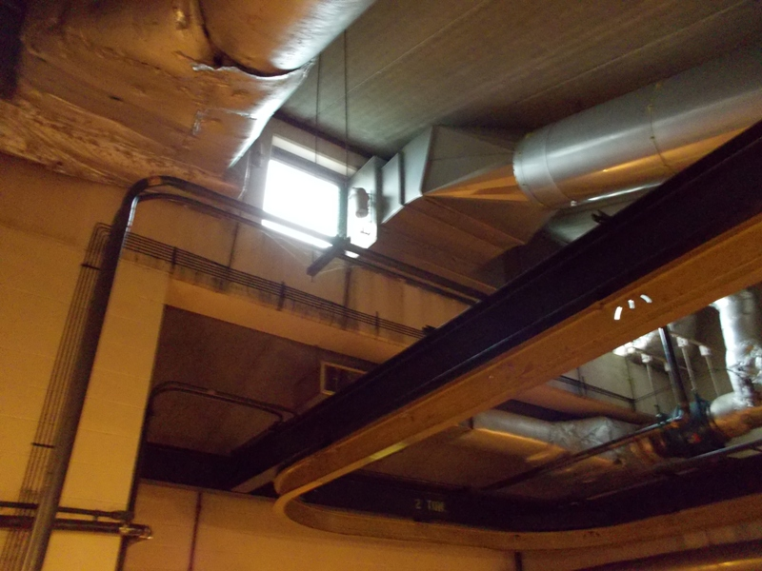

Windows for Natural Light
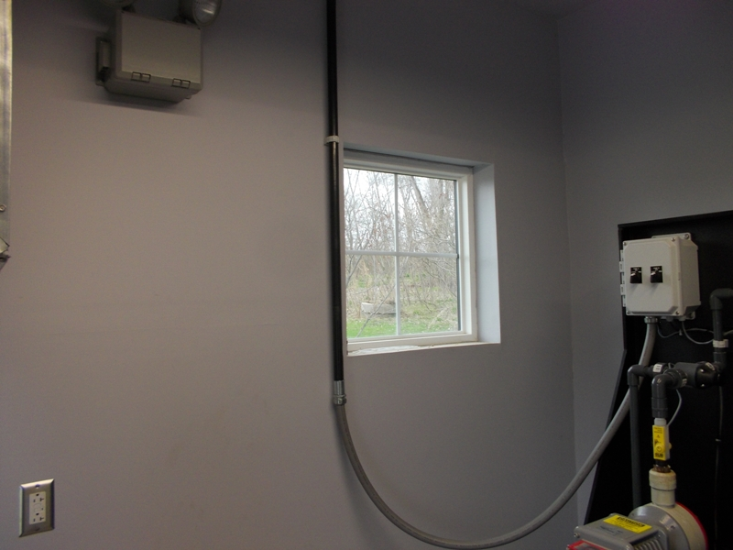

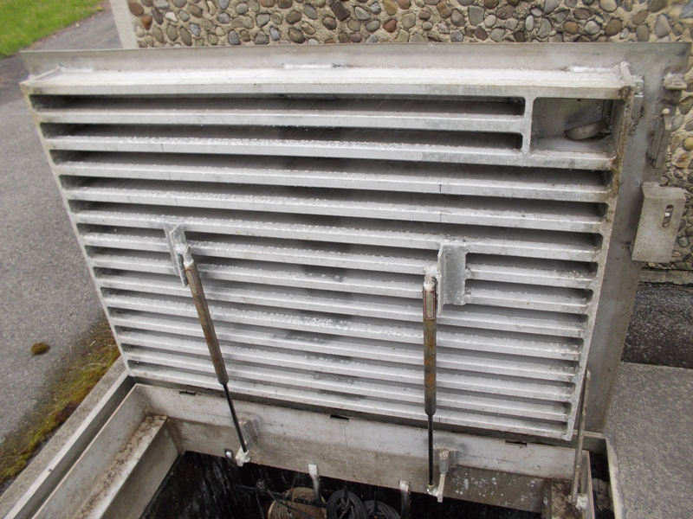

Hatch Doors

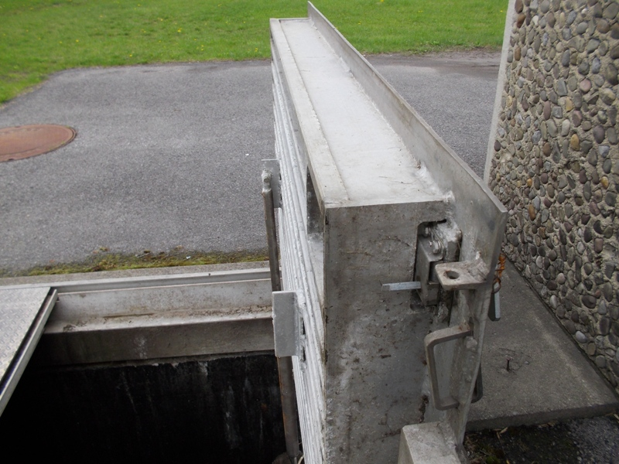
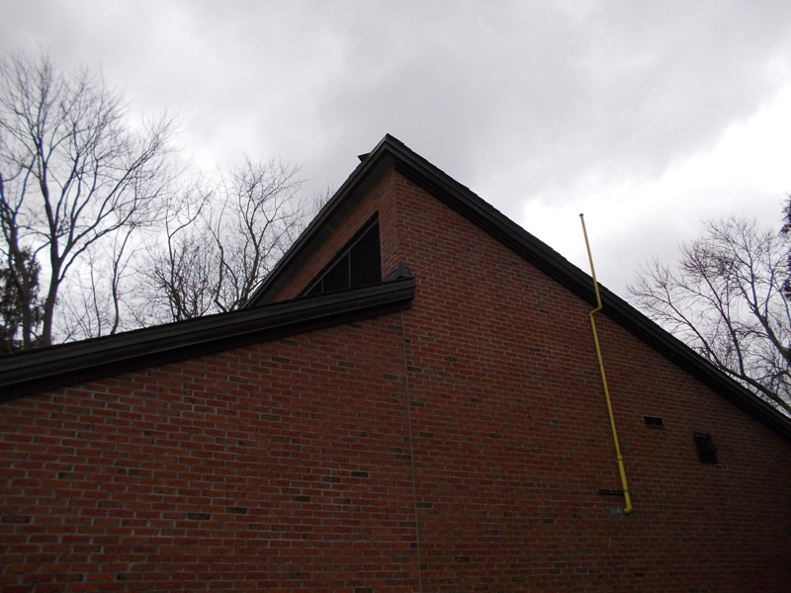

Types of Exterior Finish

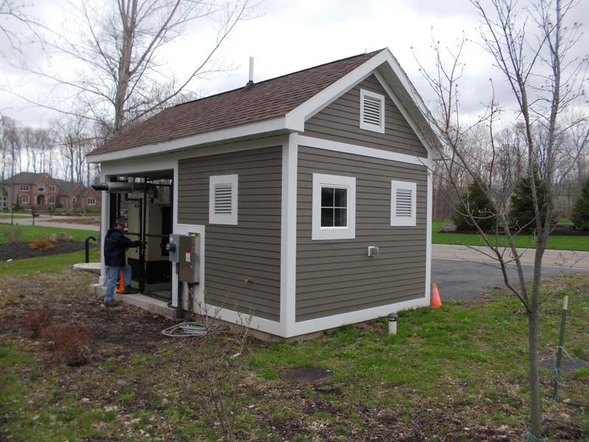

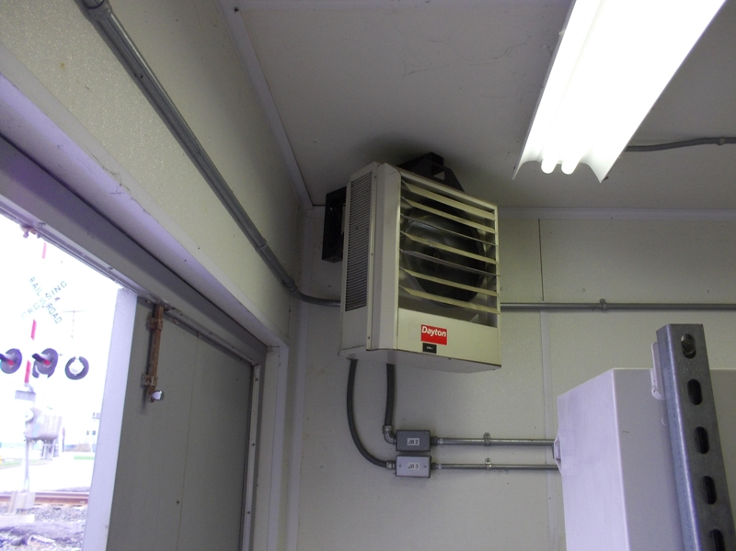

Heating and Ventilation

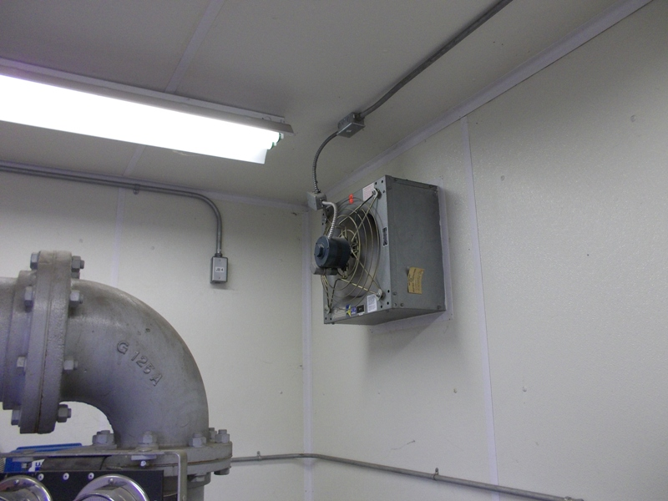

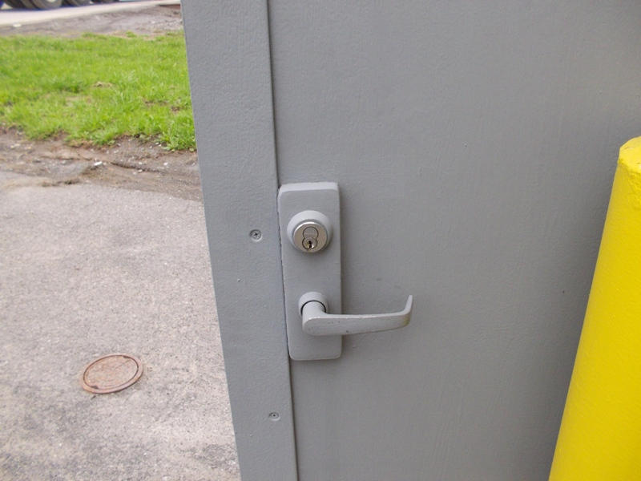

Door Latch, Interior Crash Bar

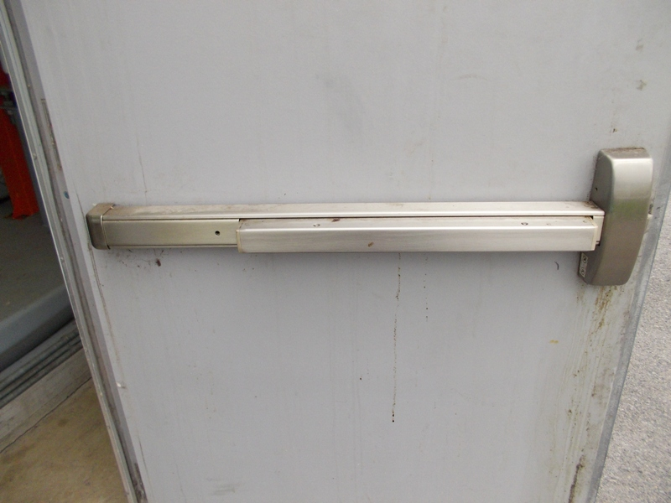

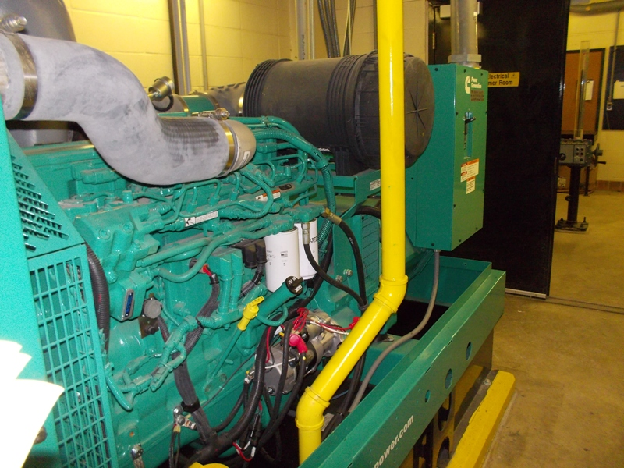

Generator and Fuel Containment

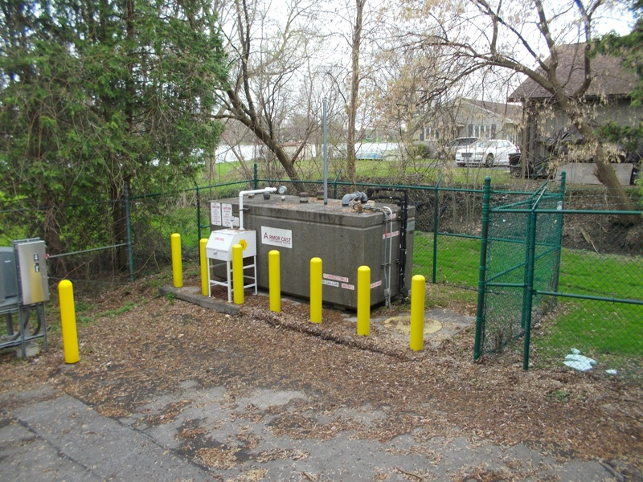

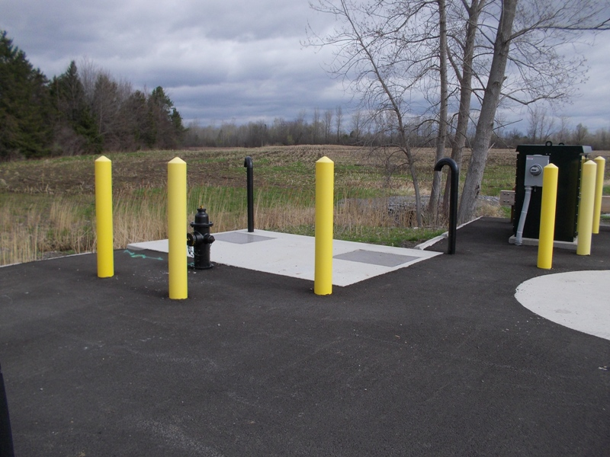

Bollards Protect Hydrant, Vent, Controls

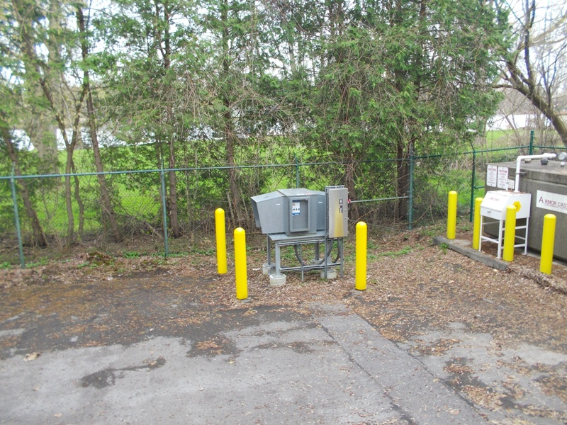
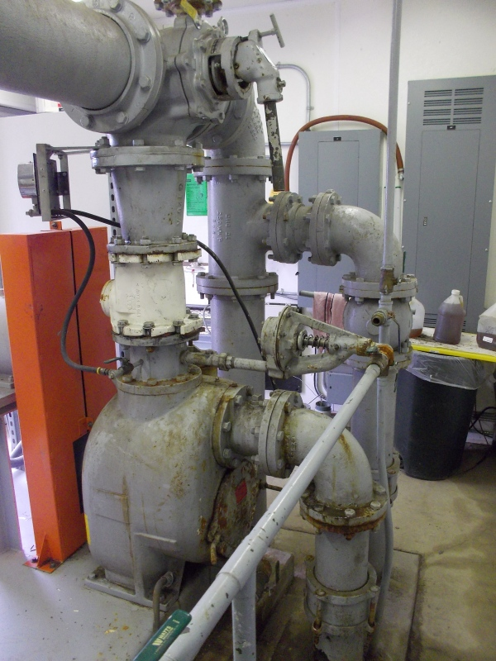

Painted Piping

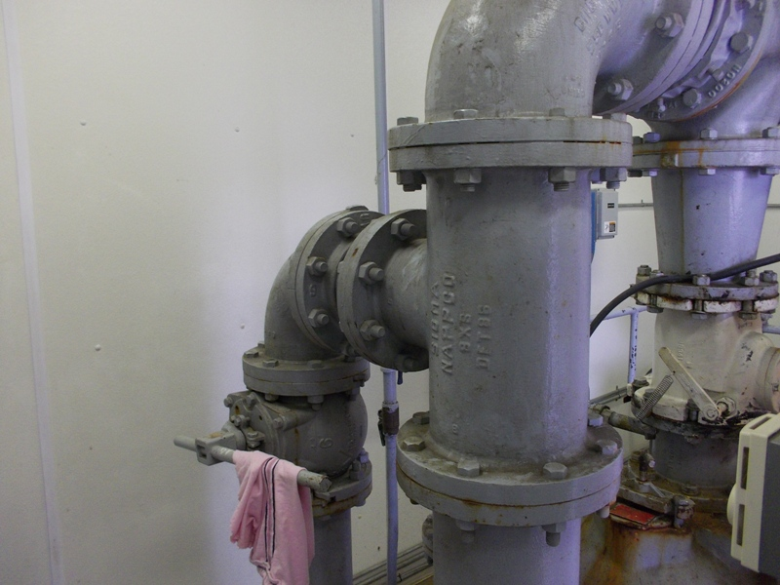

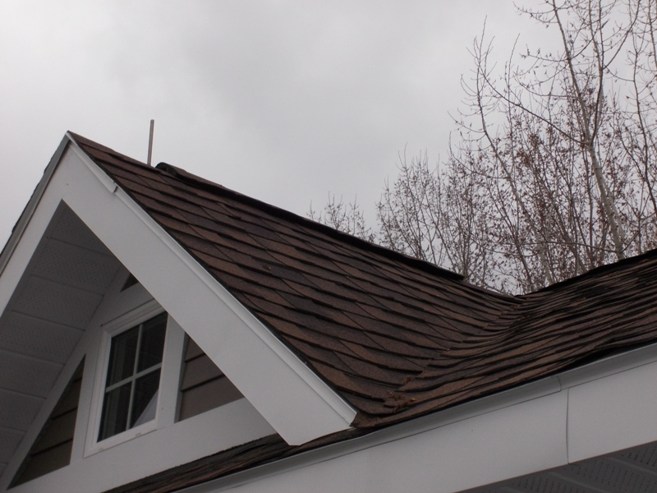

Roof Types

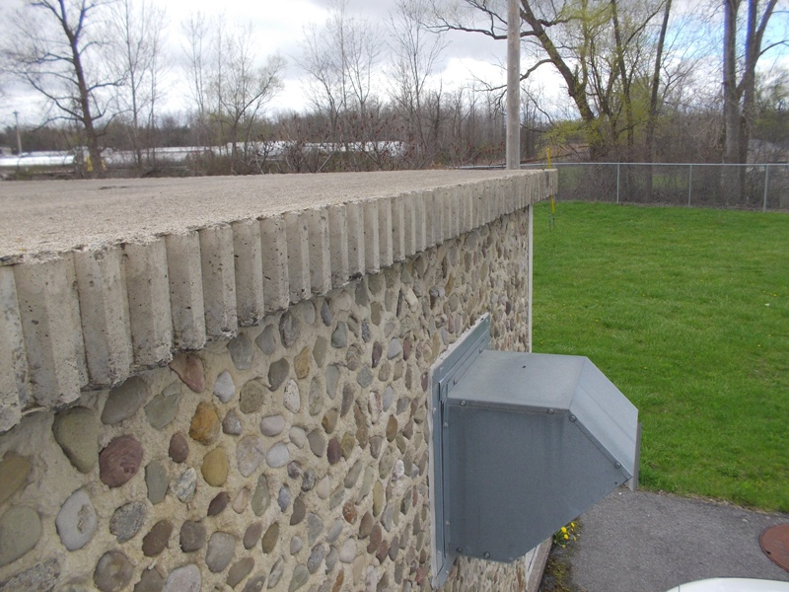
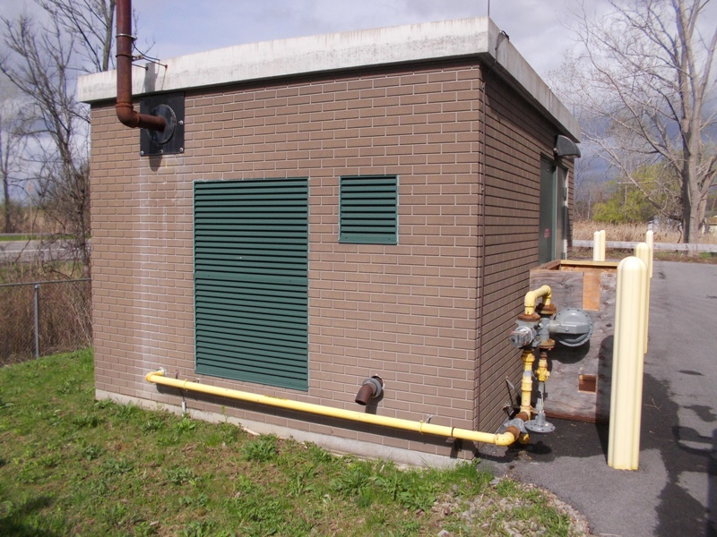

Station Styles
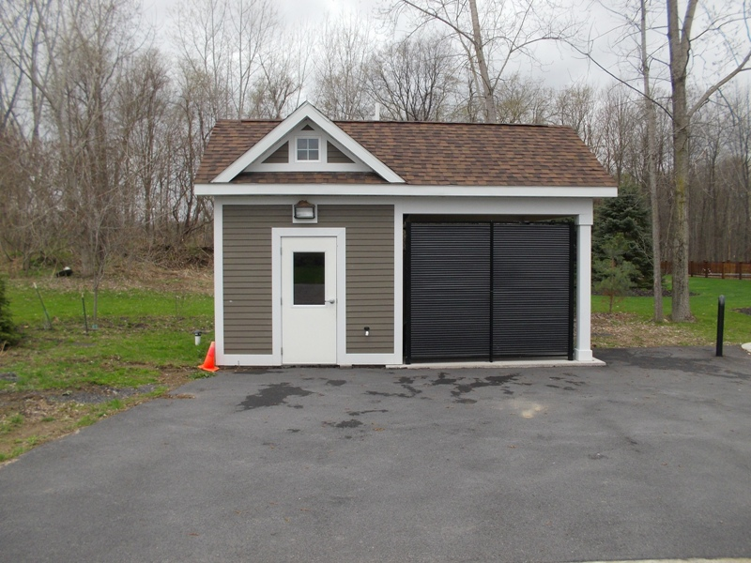
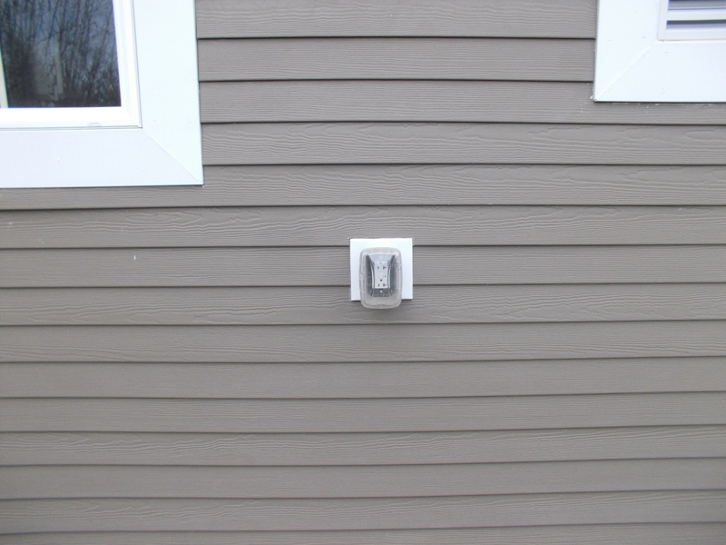

Exterior Power Supply

Maintenance Free Soffit
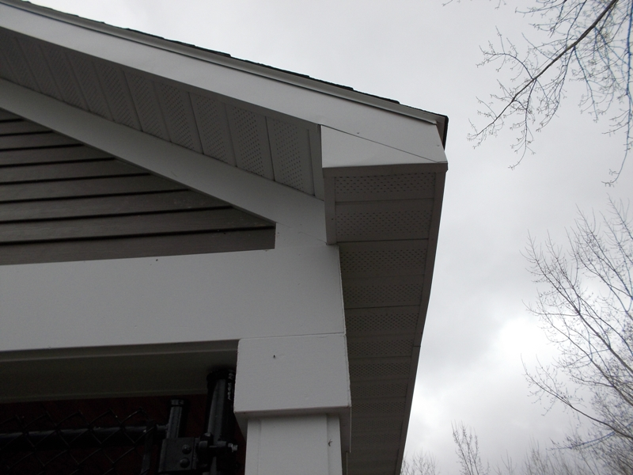

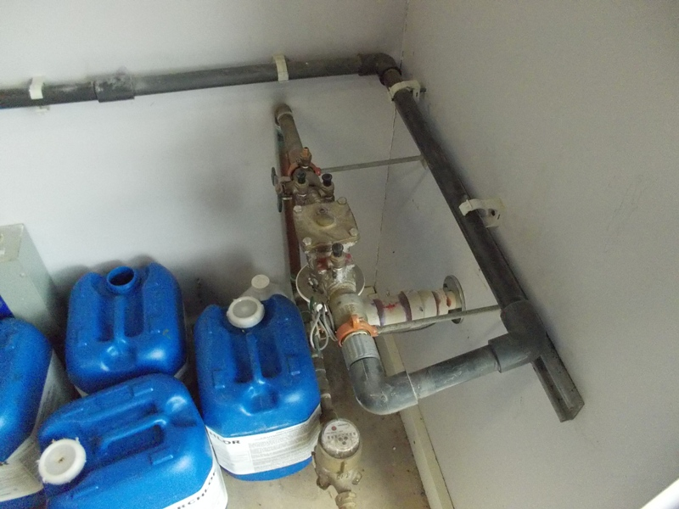
Backflow Preventer

Cane Vent and Bypass Hydrant

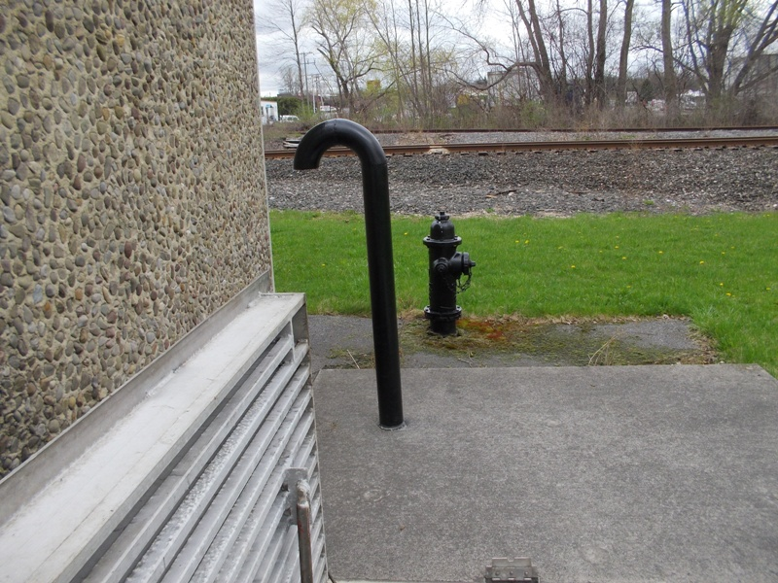

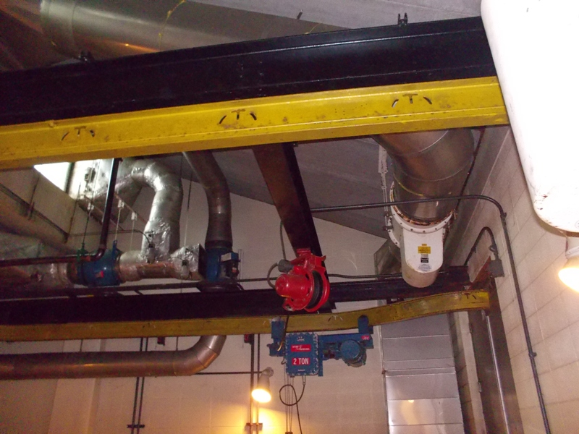

Overhead Crane System

Power Louvre Ventilation
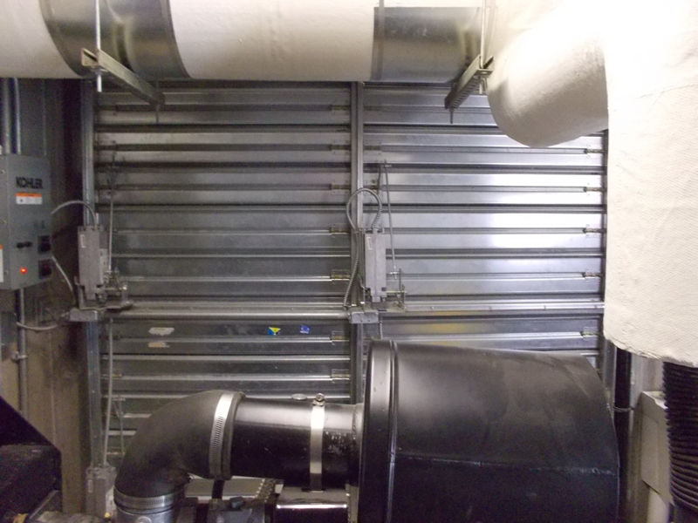

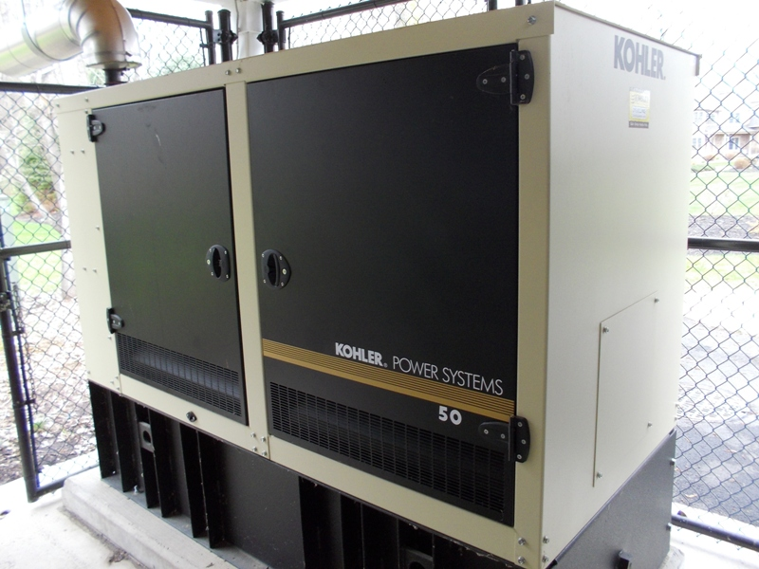

Generator and Control Panels
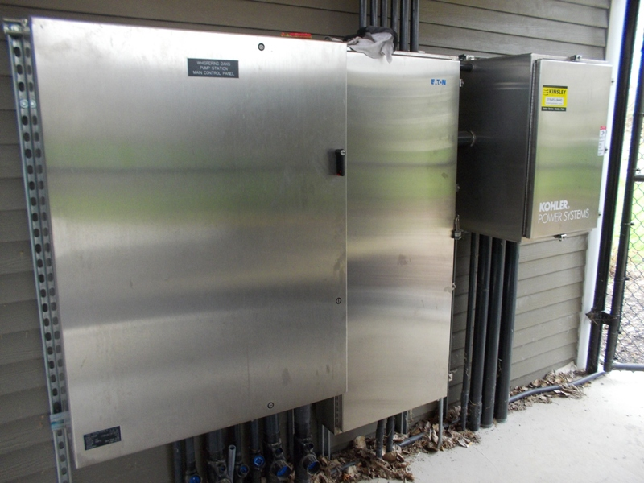
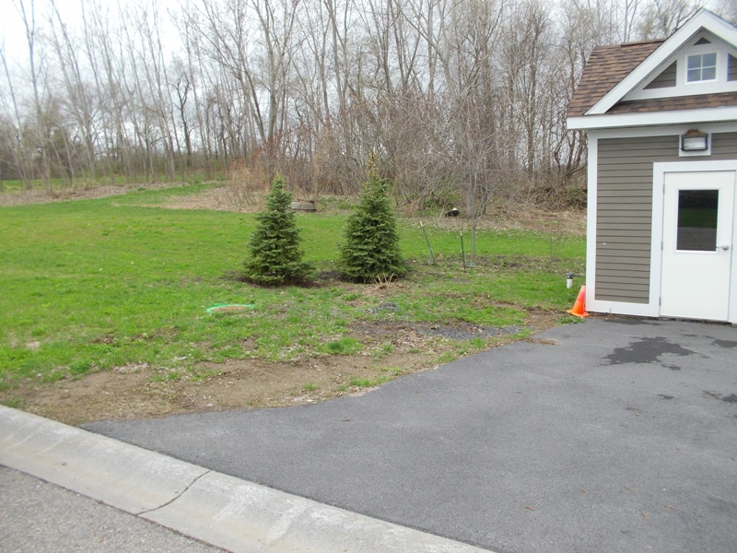
Landscaping/Noise Control

Valve Pit

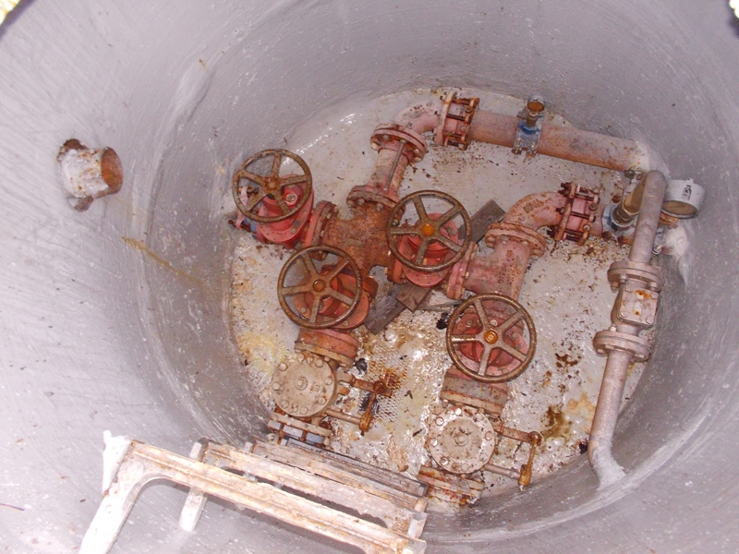
Onondaga County Department of Water Environment Protection
Standard for Design and Construction of
Wastewater Pumping Stations

ONONDAGA COUNTY DEPARTMENT OF WATER ENVIRONMENT PROTECTION
STANDARD FOR DESIGN AND CONSTRUCTION OF
WASTEWATER PUMPING STATIONS

APPENDIX D

REFERENCE STANDARDS

All references included but not limited to:

AAMA 1303.5
ACI 350.4R
American National Standards Association (ANSI)
ANSI/AWWA C151/A21.51 CL 53
ANSI A13.1- Scheme for Identification of Piping Systems
ANSI/AWWA C220
ANSI/HI 11.6-2012
ANSI/AWWA C153/A21.53
ANSI/NSF Standard 60
ANSI/AWWA C509 or C515
ANSI/AWWA C508
ANSI/AWWA C900
American Petroleum Institute (API)
ASCE 7-05
American Society of Mechanical Engineers (ASME)
ASME Boiler and Pressure Vessel Code
ASME B31.4- Liquid Pipelines
ASME Section VIII- Pressure Vessels
American Society for Testing and Materials (ASTM)
ASTM C923 "Specification for Resilient Connectors between Concrete Manhole Structures, Pipes, and Laterals"
ASTM D698
ASTM D1557
ASTM M30 P1
ASTM D4637/ D4637M
ASTM D6083
ASTM D6694
ASTM D6947
ASTM D7425
ASTM D3273
ASTM C216-97
ASTM C1029
ASTM C1396
ASTM E547/E331
ASTM E283
ASTM E987
ASTM E330
ASTM A351, CF8M
American Water Works Association (AWWA)
AWWA/ANSI C115/A21.15
AWWA C900- cement lined ductile iron pipe or PWC pipe
AWWA 4.4.6/ 4.4.2
BHMA 156.1
BHMA 156.13
Electronic Industries Association (EIA)
EPA Class I Reliability Standards
Institute of Electrical and Electronics Engineers, Inc. (IEEE)
IEEE Standard 142 for Grounding
IEEE C62 for application of Transient Voltage Surge Suppression
SI/IE IEEE Standard 142 for Grounding EE Standard 141 for Motor Control Equipment
IEEE Std. 142-2007
IEEE Std. 242-2001
IEEE Std. 1100-1999
IEEE 241
IEEE C62.41-1991
Insulated Cable Engineers Association, Inc. (ICEA)
International Building Code
LPI-175
LPI-177
National Association of Pipe Fabricators (NAPF)
National Electrical Code (NEC)
National Electrical Code 2011 E
NEC Class I Division I
NEC- Article 220-3
National Electrical Contractors Association (NECA)
NEIWPCC TR-16 3.8.3
NEIWPCC TR-16 3.8.4
National Electrical Manufacturers Association (NEMA)
NEMA Standards Electrical Manufacturers Association
National Electrical Safety Code (NESC)
National Fire Protection Association (NFPA)
New York State Design Standards for Intermediate Sized Wastewater Treatment Systems
NFPA 820, Standard for Fire Protection in Wastewater Treatment and Collection Facilities
NFPA 70, National Electric Code, as Class 1, Division 1 and Class 1, Division 2 hazardous areas and unclassified areas
National Fire Protection Association 820 AN
New York State Department of Environmental Conservation
NFPA 820
NFPA 79
NFPA 30
NFPA 780
NFPA- National Electrical Code 1996 Handbook
National Safety Fire Protection Code
New York State Cross Connection Control Regulations (NYCRR)
NYCRR5-1.31
Occupational Safety and Health Agency (OSHA)
OSHA Standard 1910.24
Ten States Standards
Underwriters Laboratories, Inc. (UL)
UL Inc. Electrical Institution Materials Directory
UL 1449- Standard for Safety for Surge Protective Devices
UL Standard 142
UL 2085
UL 96
UL 96A
Uniform Building Code (UBC)
Uniform Fire Code
UFC Test Standard (Article 79 or Appendix #

